**Project - 1: Deploying a Multi-Tier Website Using AWS EC2**

**Problem Statement:**

Company ABC wants to move their product to AWS. They have the following things set up right now:

1. MySQL DB

2. Website (PHP)

The company wants high availability on this product, therefore wants Auto Scaling to be enabled on this website.

**Steps To Solve:**

1. Launch an EC2 Instance

2. Enable Auto Scaling on these instances (minimum 2)

3. Create an RDS Instance

4. Create Database & Table in RDS instance:

a. Database name: intel

b. Table name: data

c. Database password: intel123

5. Change hostname in website

6. Allow traffic from EC2 to RDS instance

7. Allow all-traffic to EC2 instance

* Launching an EC2 instance!

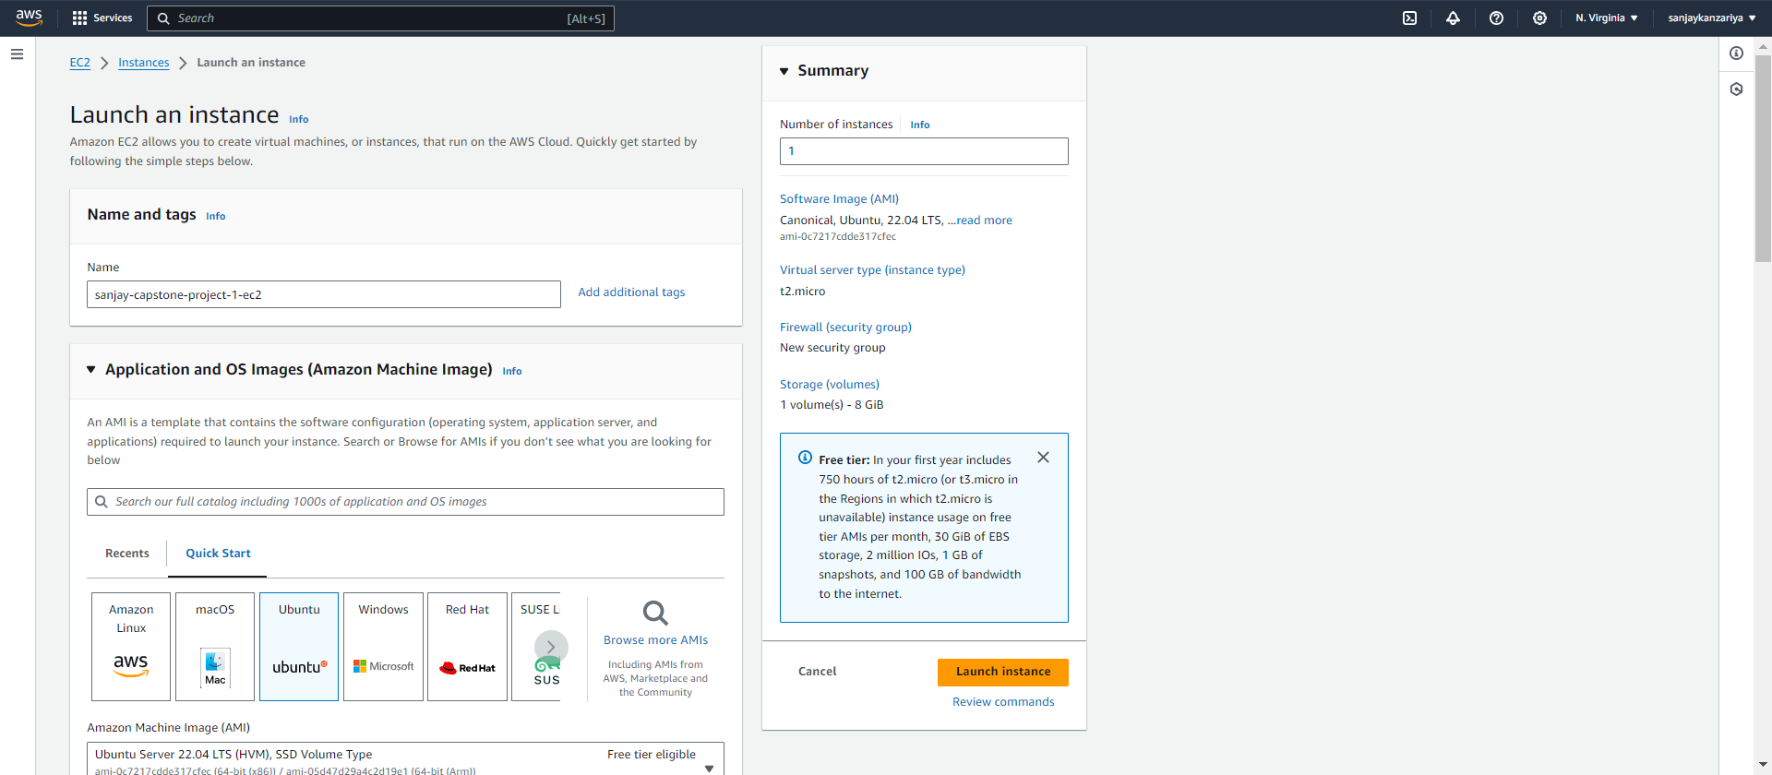

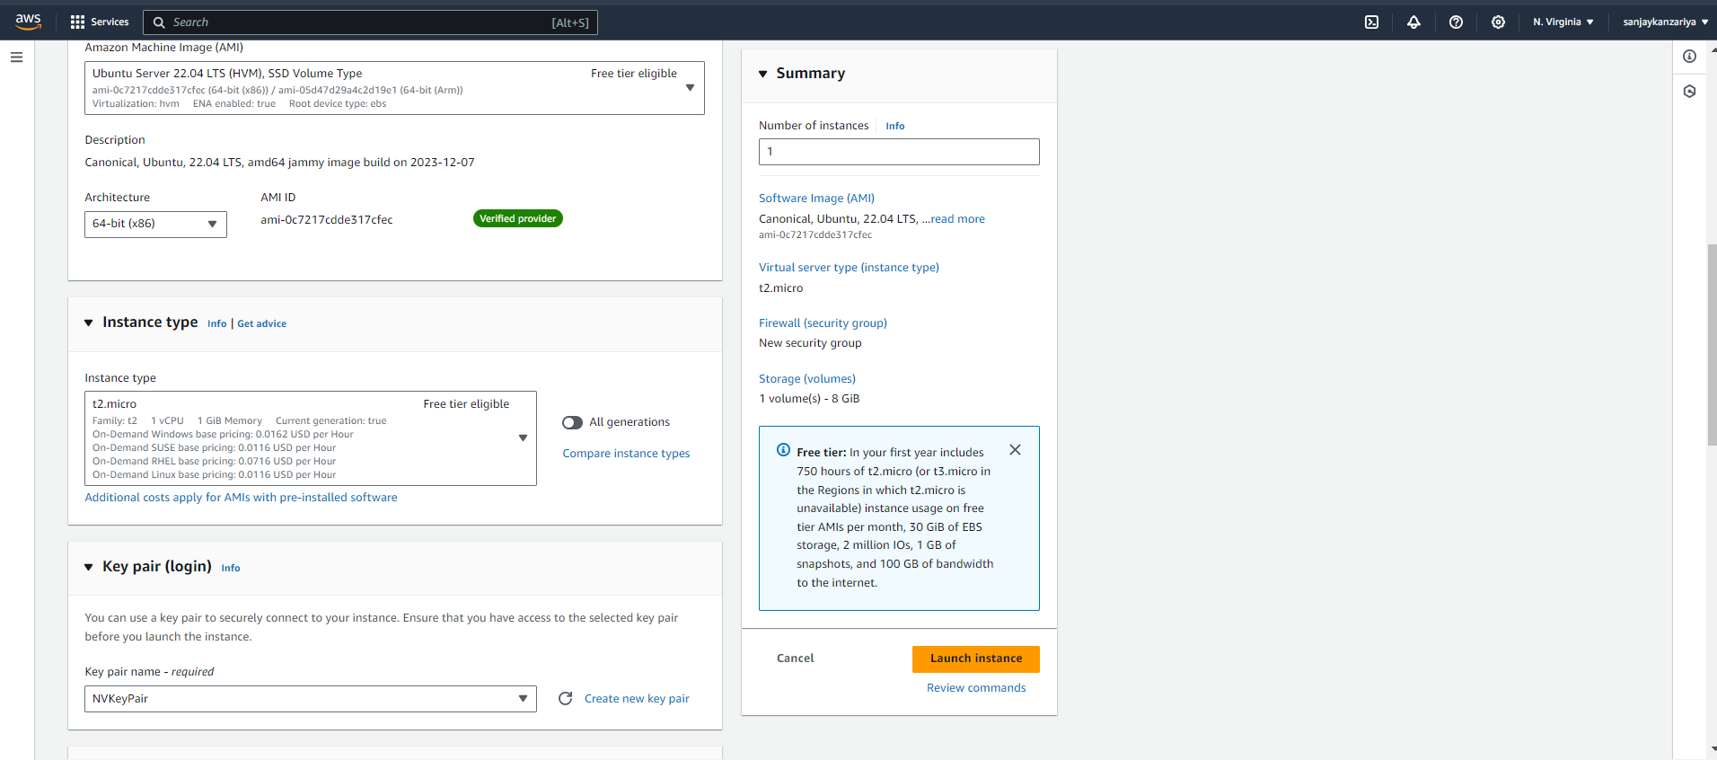

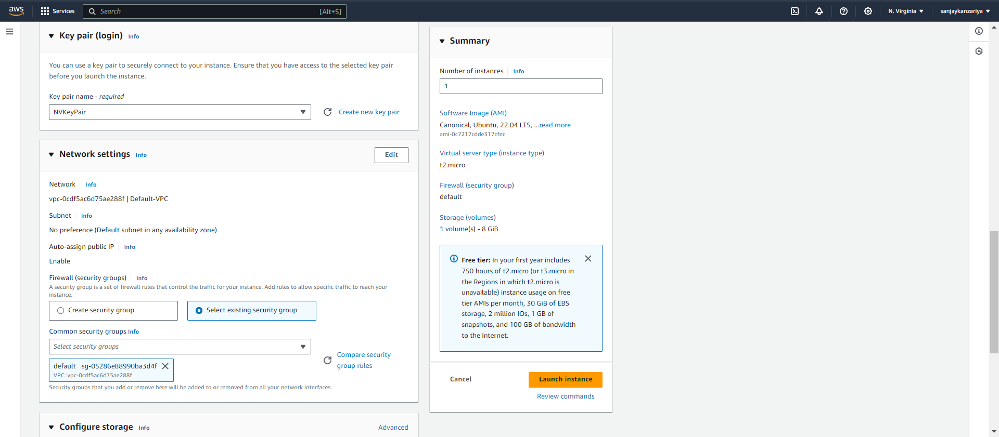

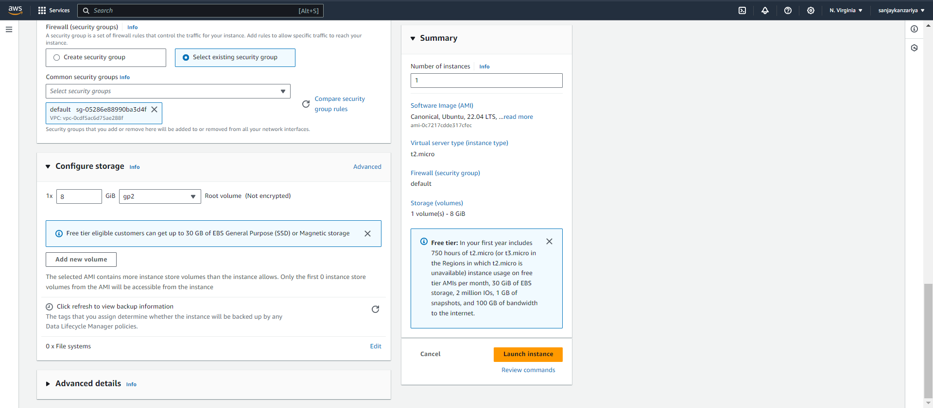

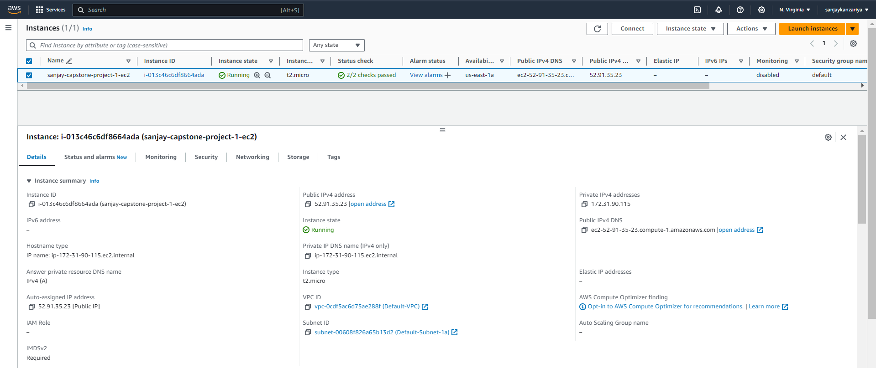

* Connecting to Instance and updating it!

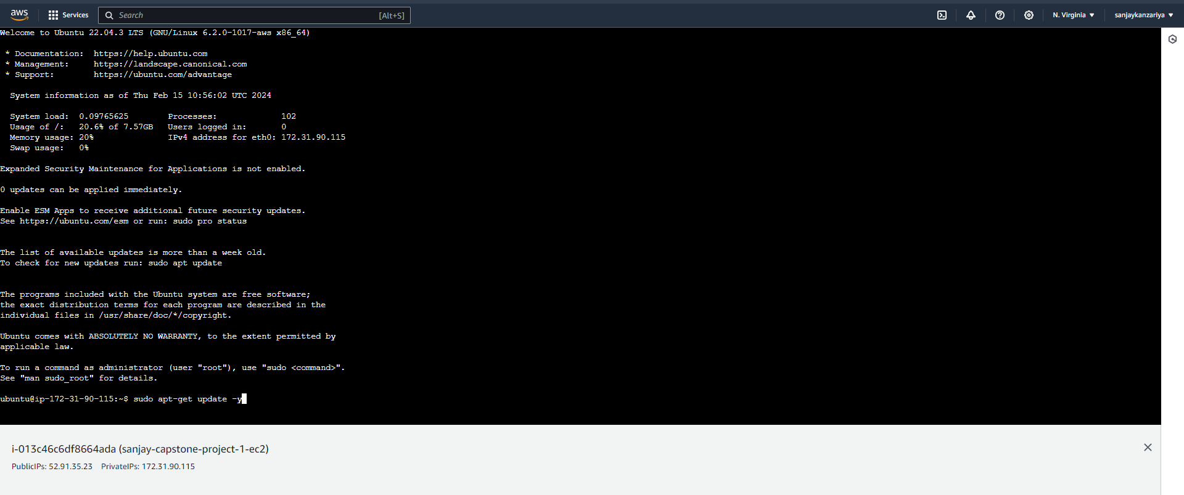

* Installing Apache server to EC2 instance!

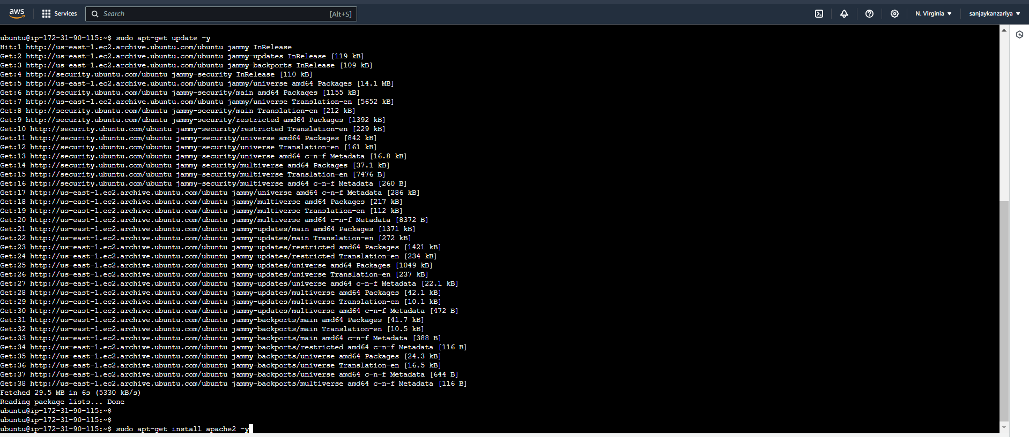

* Apache Server installed in EC2 instance!

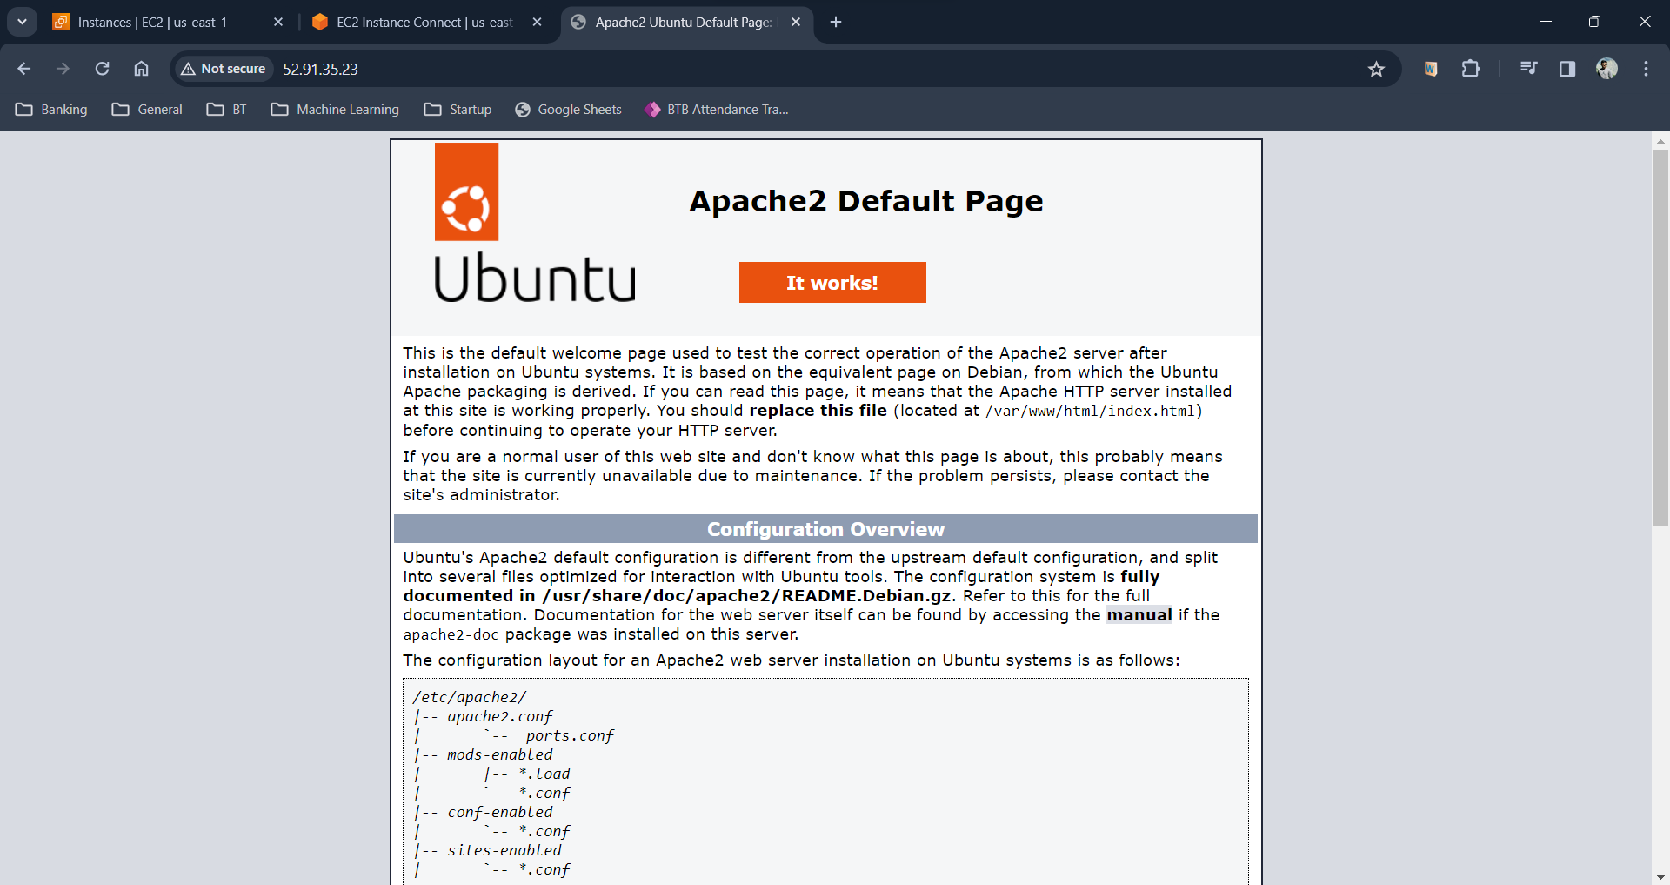

* Deleting default index.html file of Apache server!

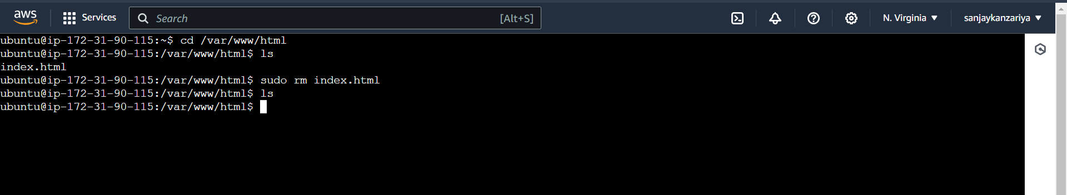

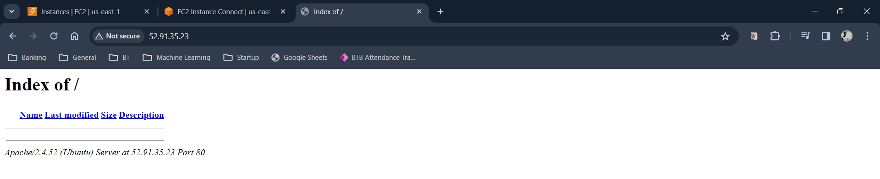

* Uploading code (PHP) of our custom website to EC2 Instance!

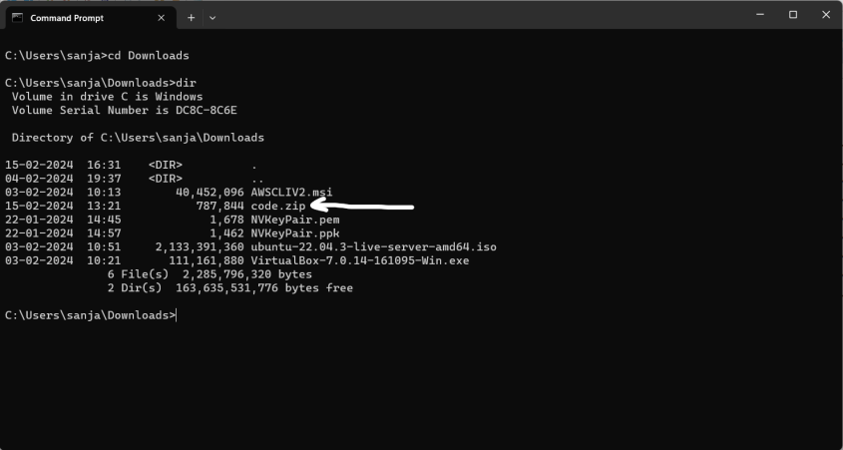

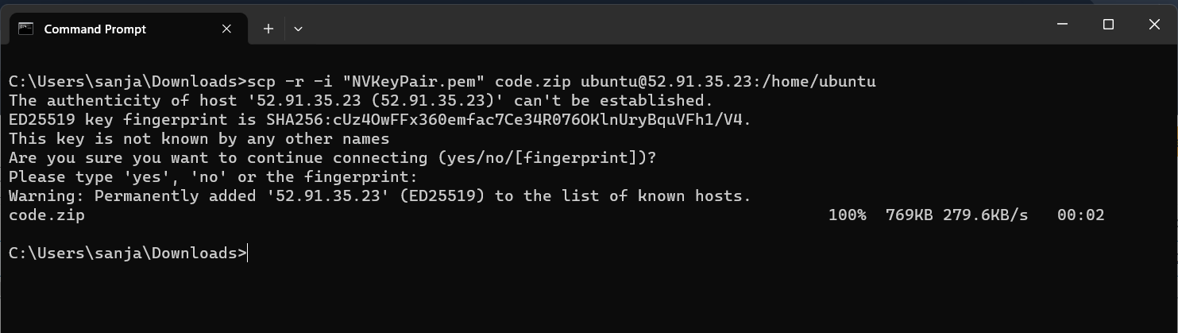

* Checking if code.zip is copied to ubuntu folder!

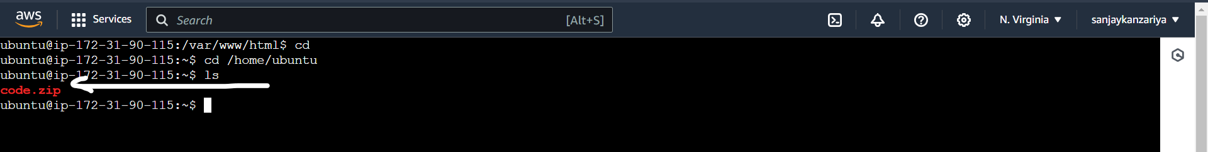

* Extracting code.zip file and moving the files to /var/www/html!

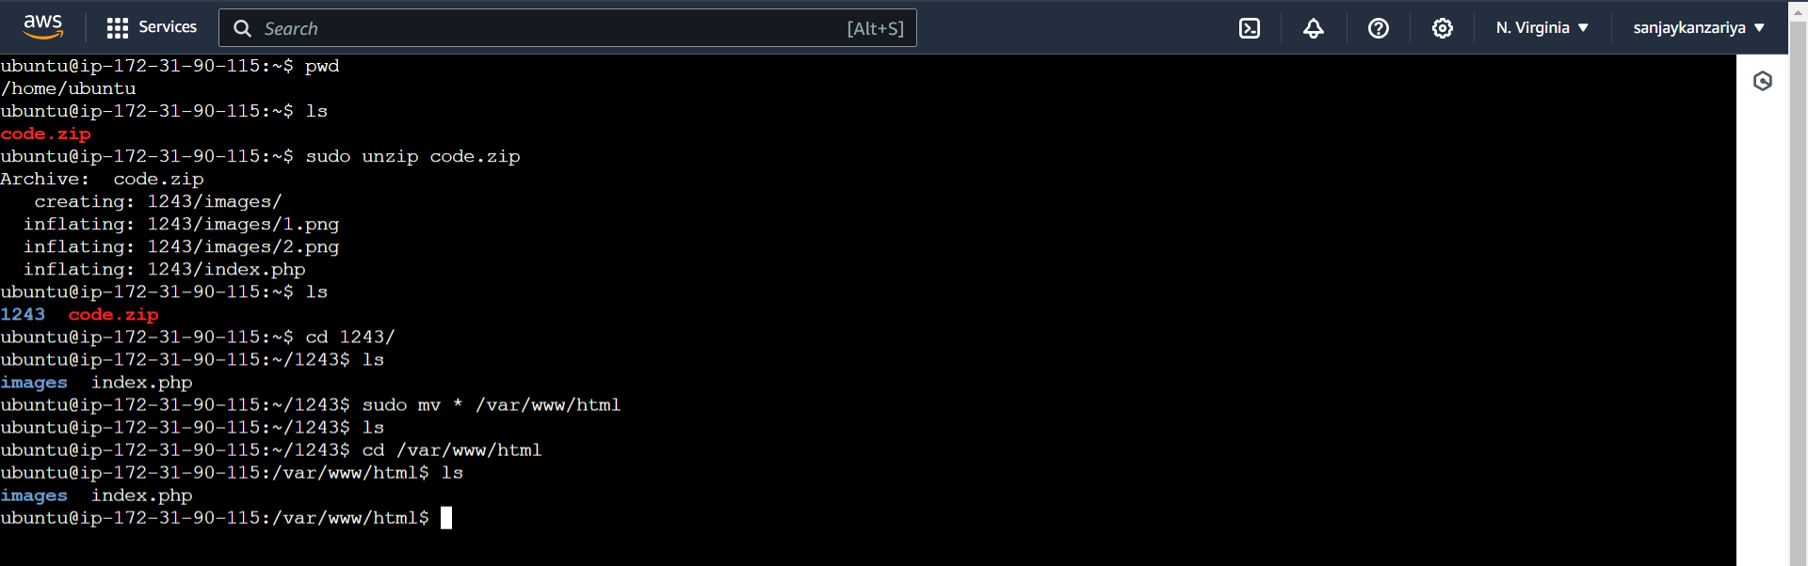

* Custom Webpage updated!

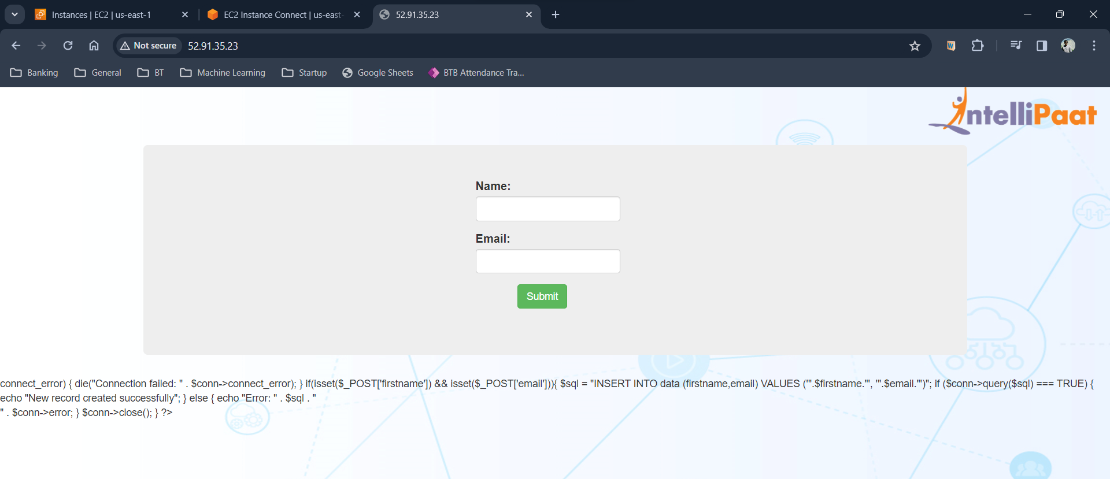

* Creating an RDS (MySQL) Instance!

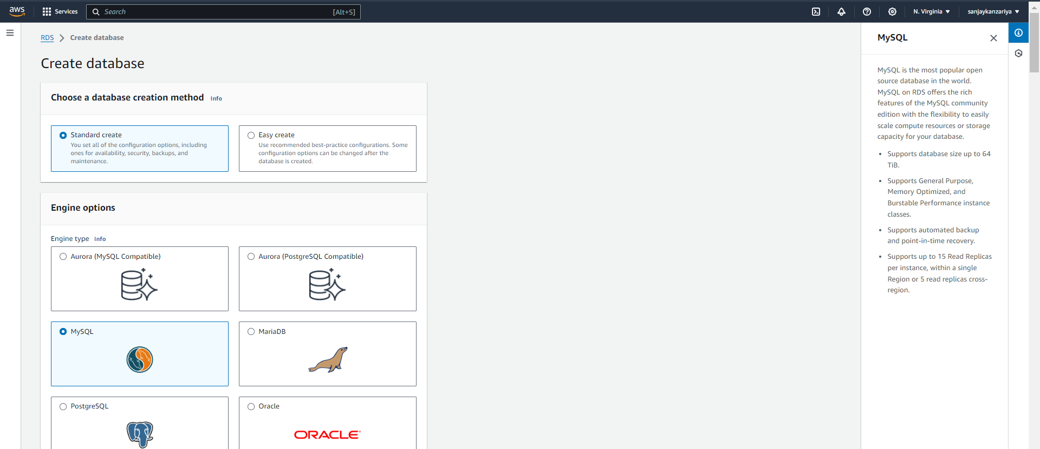

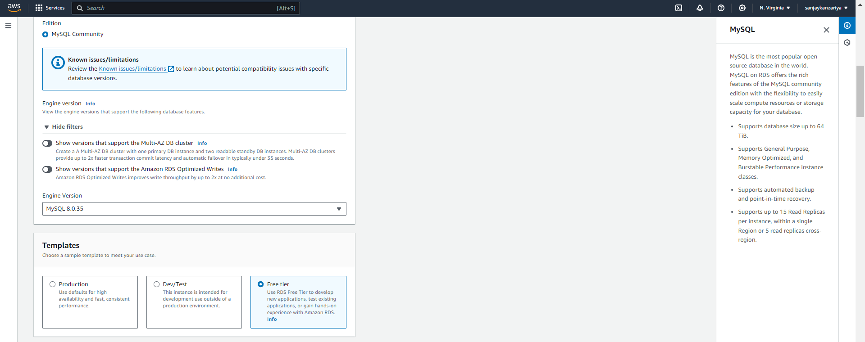

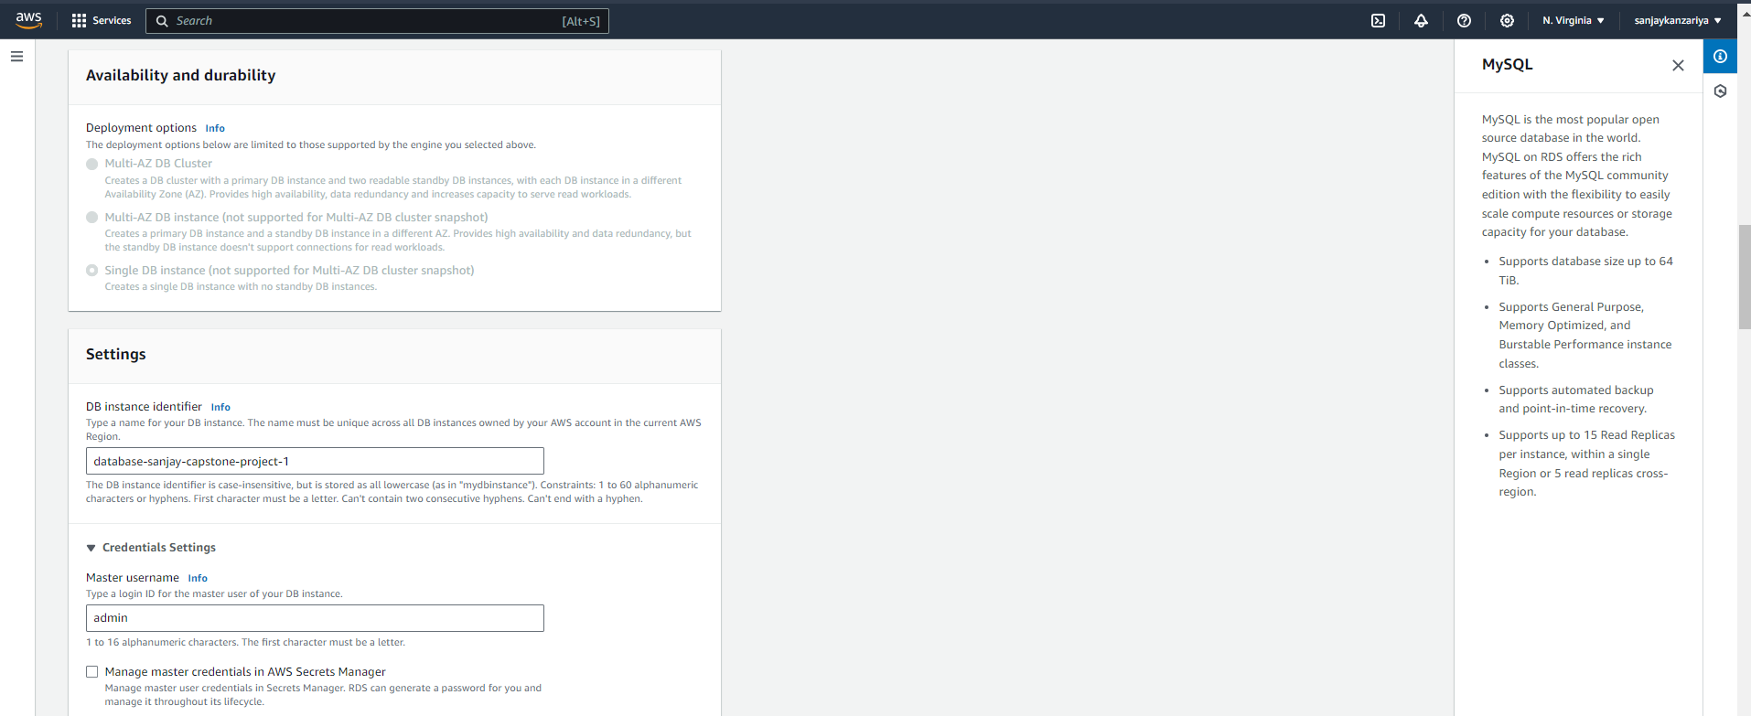

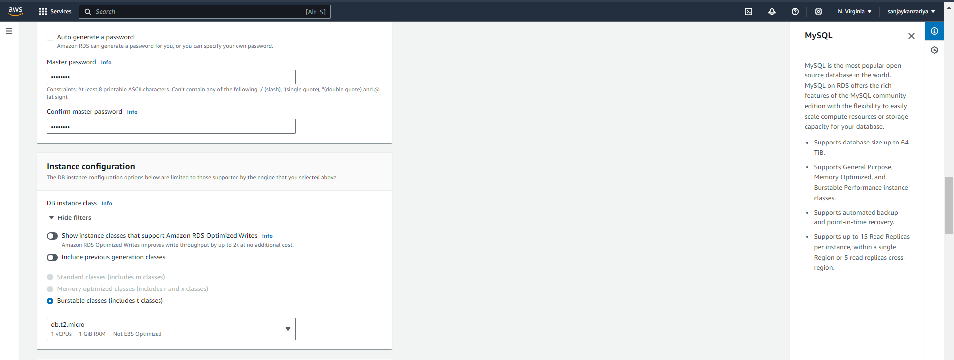

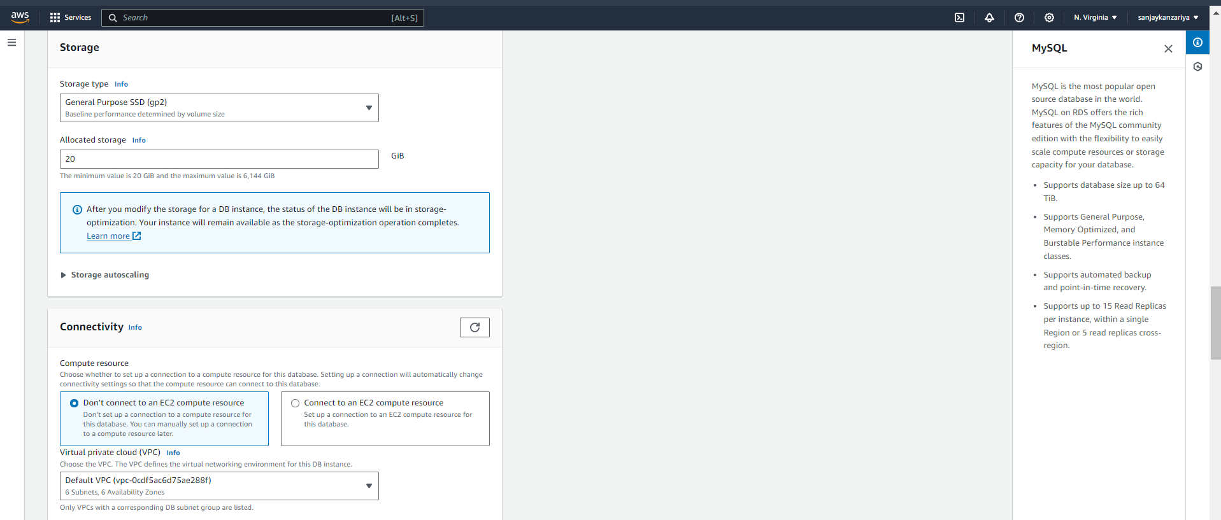

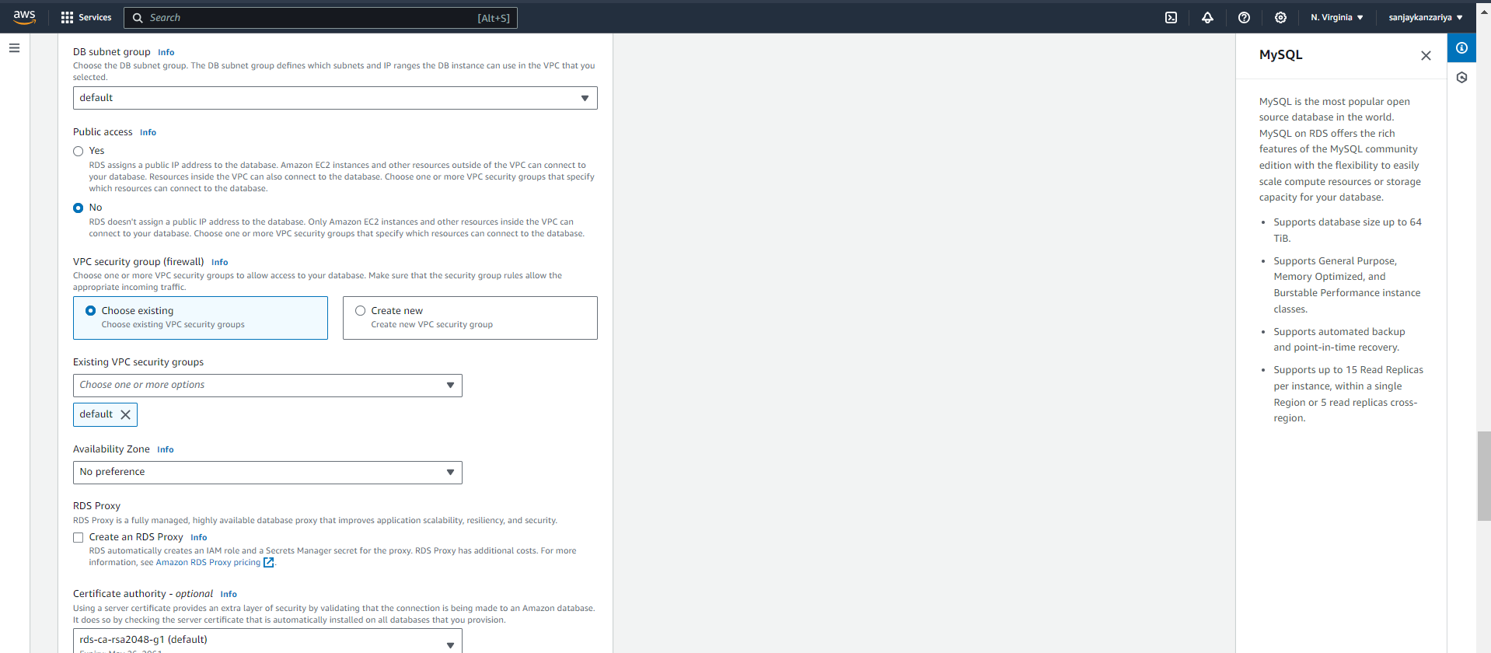

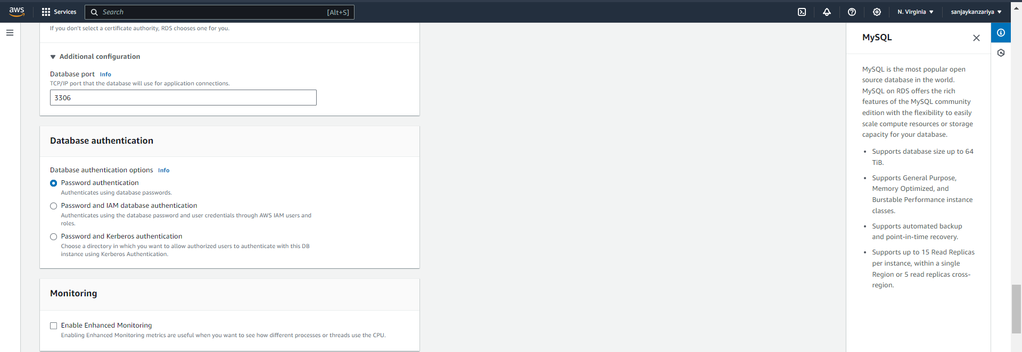

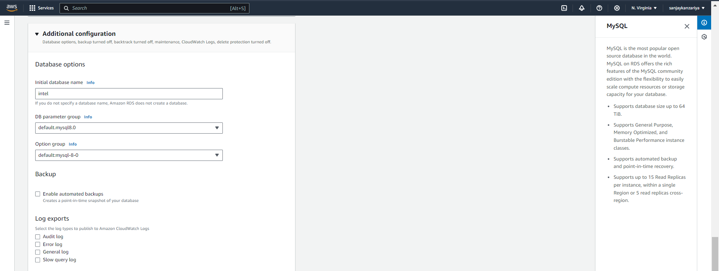

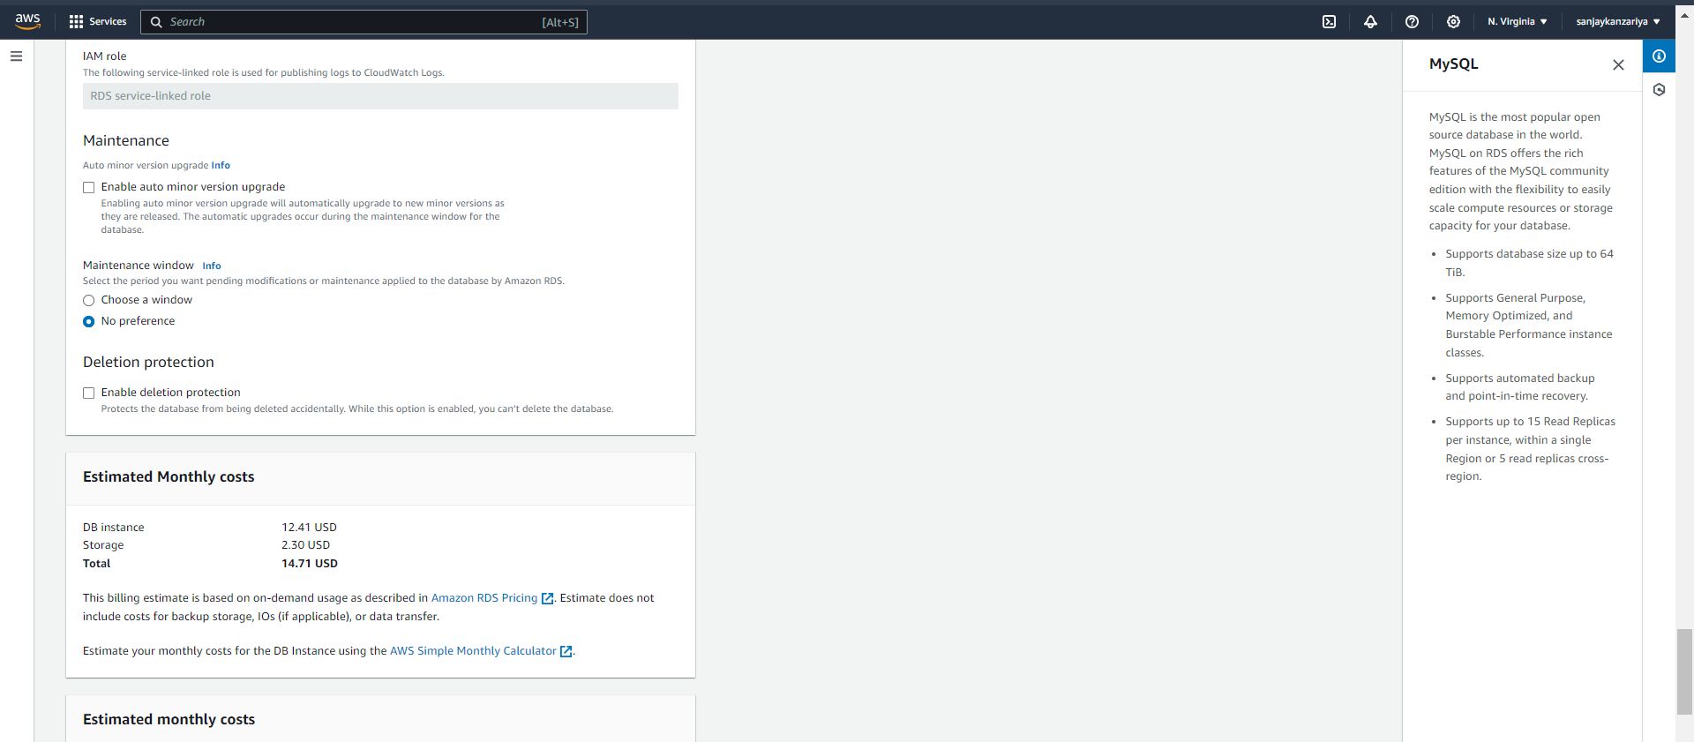

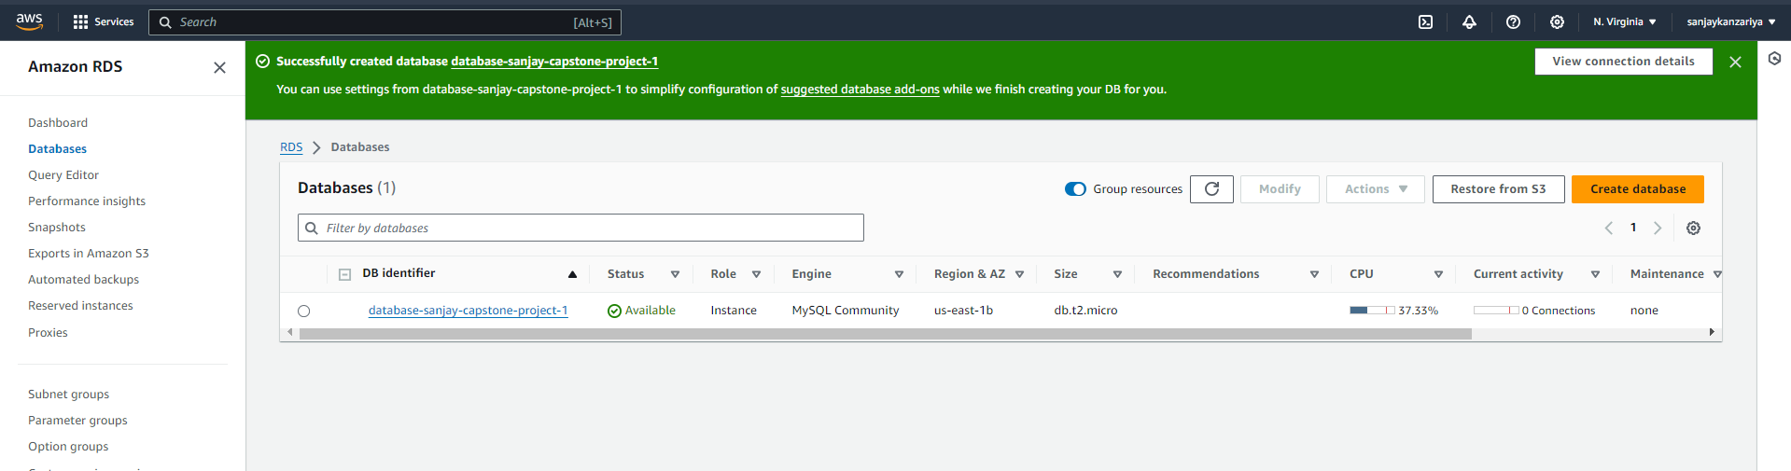

* Connecting our EC2 to this RDS instance database (intel)!

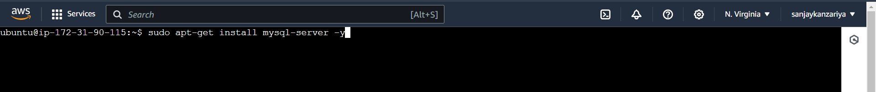

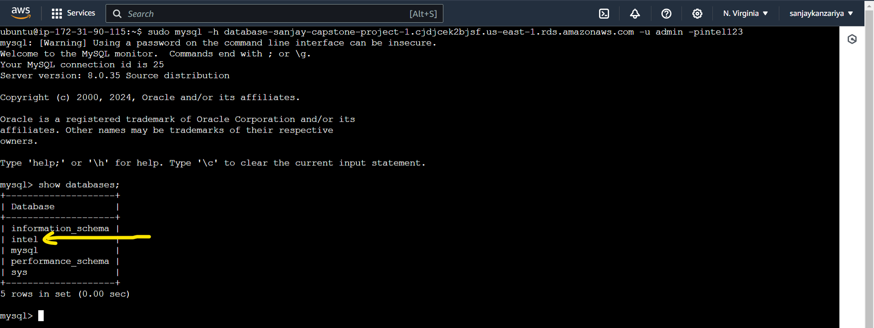

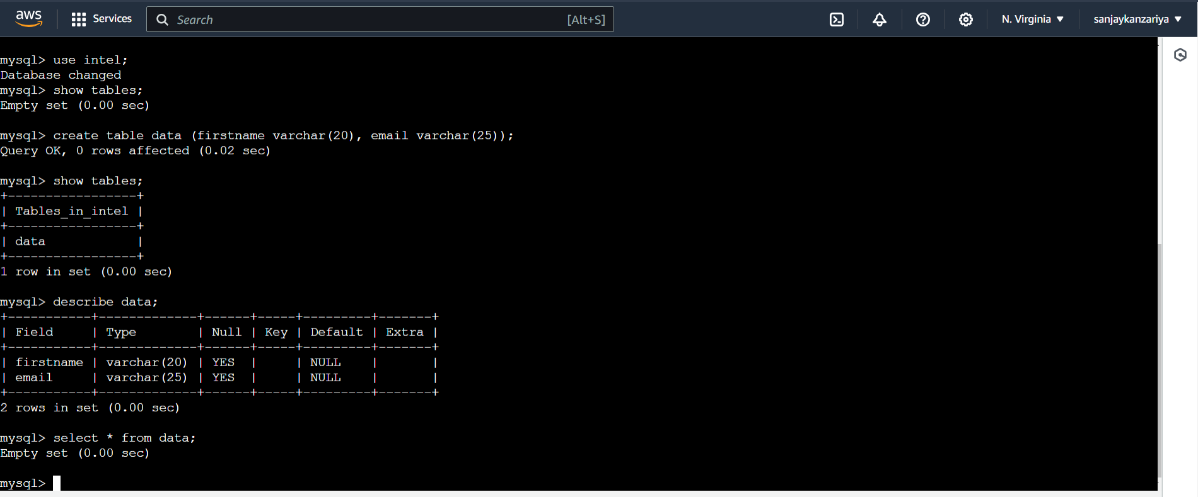

* Now, our database and table are ready, updating EC2 ENV for php website!

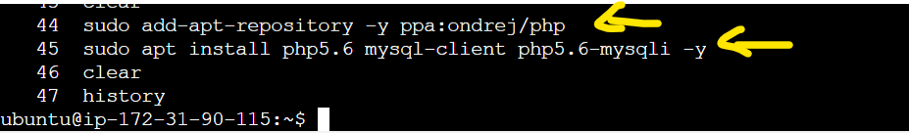

* Amending index.php file with correct database and credentials!

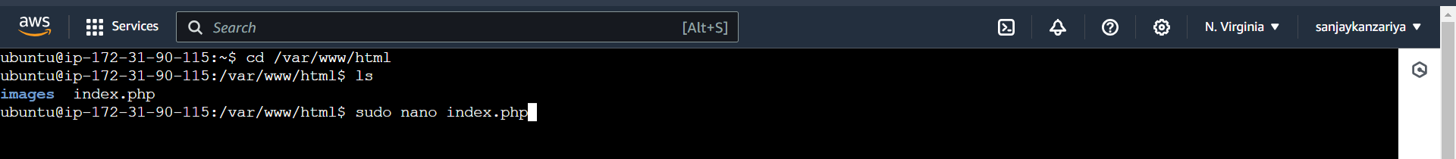

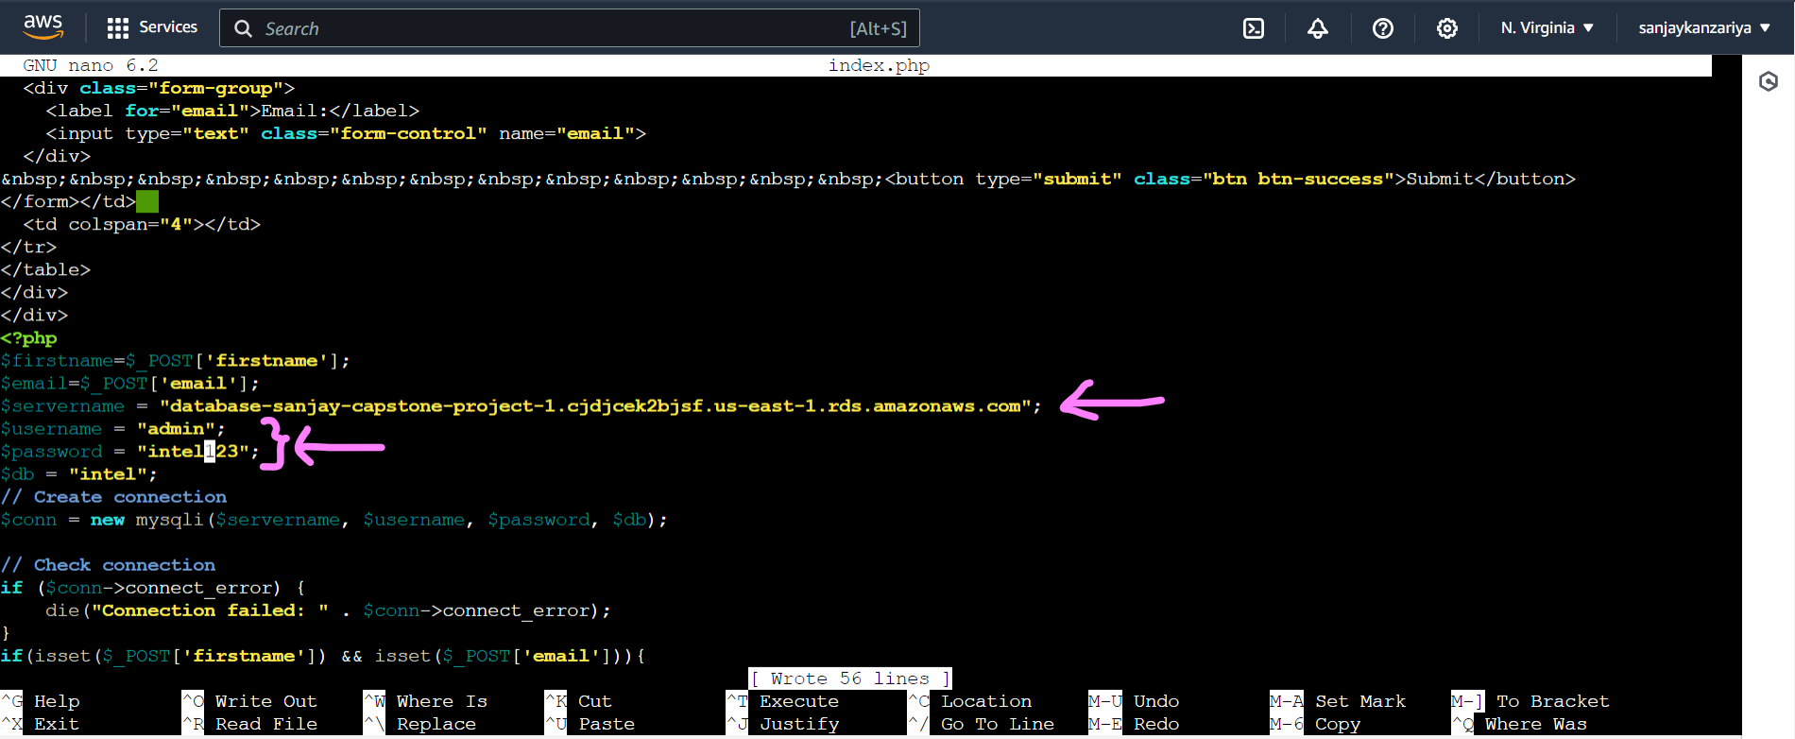

* Database connection error gone on the website!

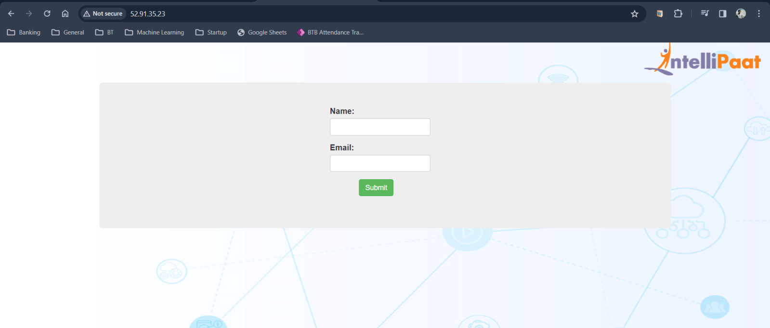

* Adding a record to the database, using primary EC2 website!

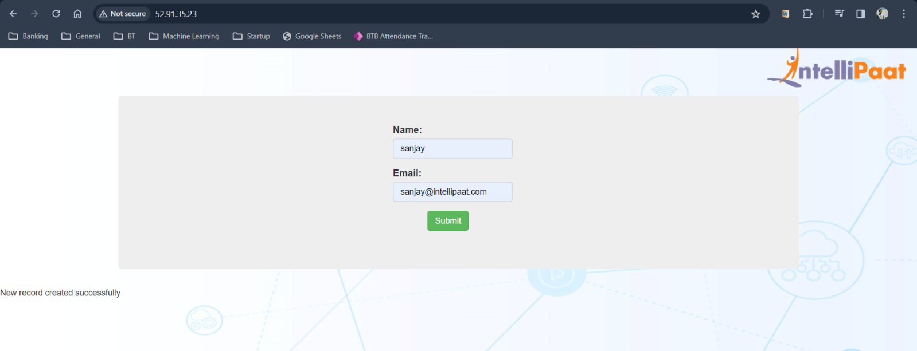

* Checking record in RDS database intel 🡪 table named ‘data’!

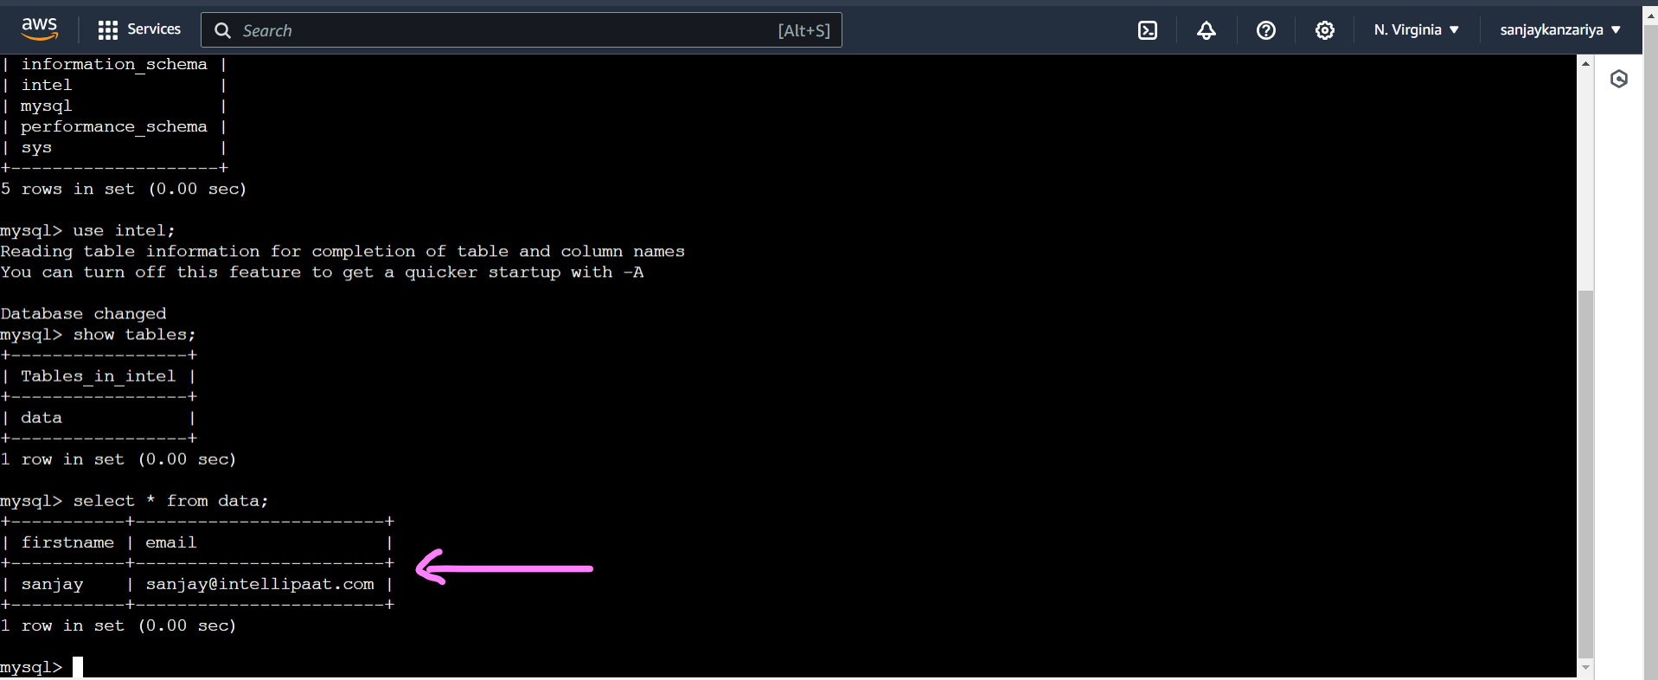

* Creating custom AMI from primary EC2 for Launch Template!

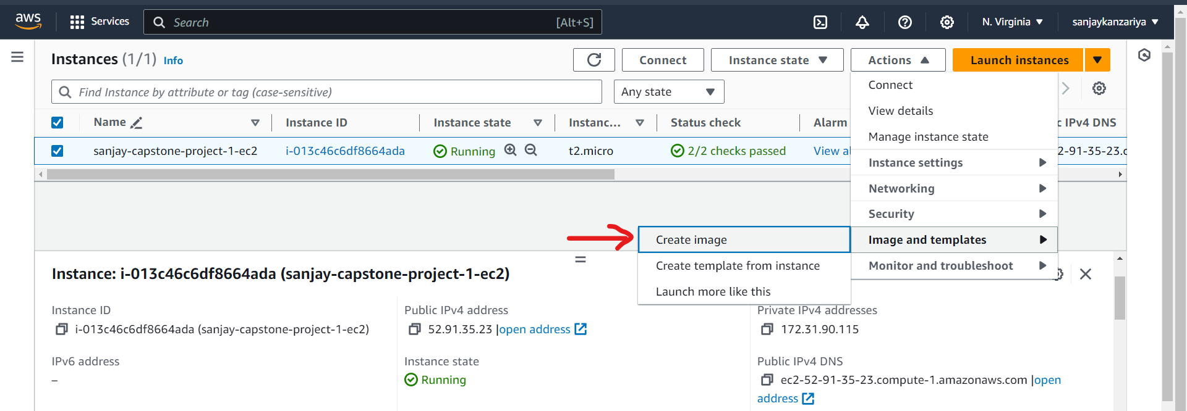

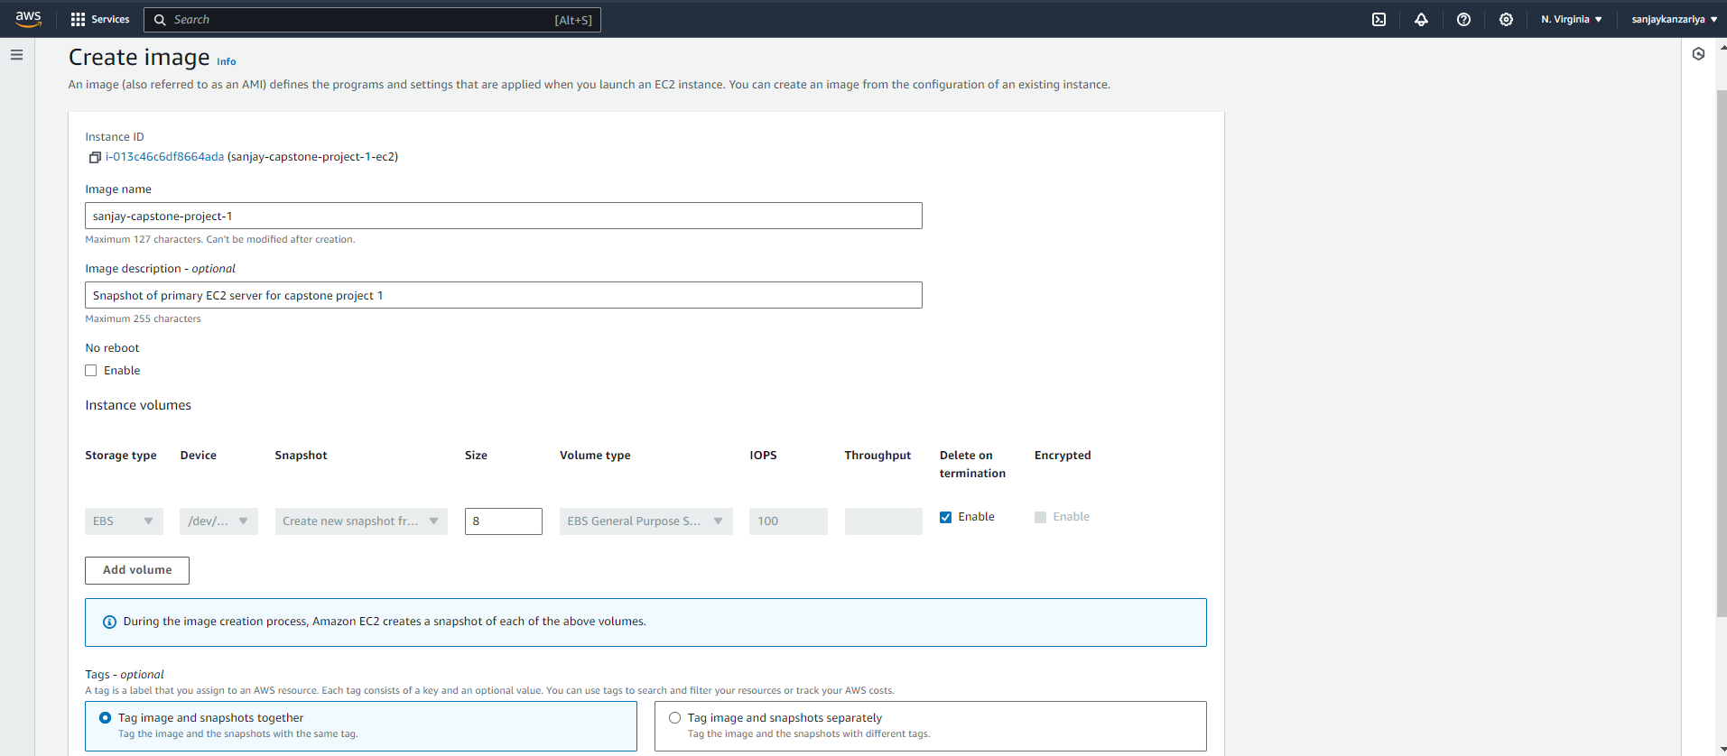

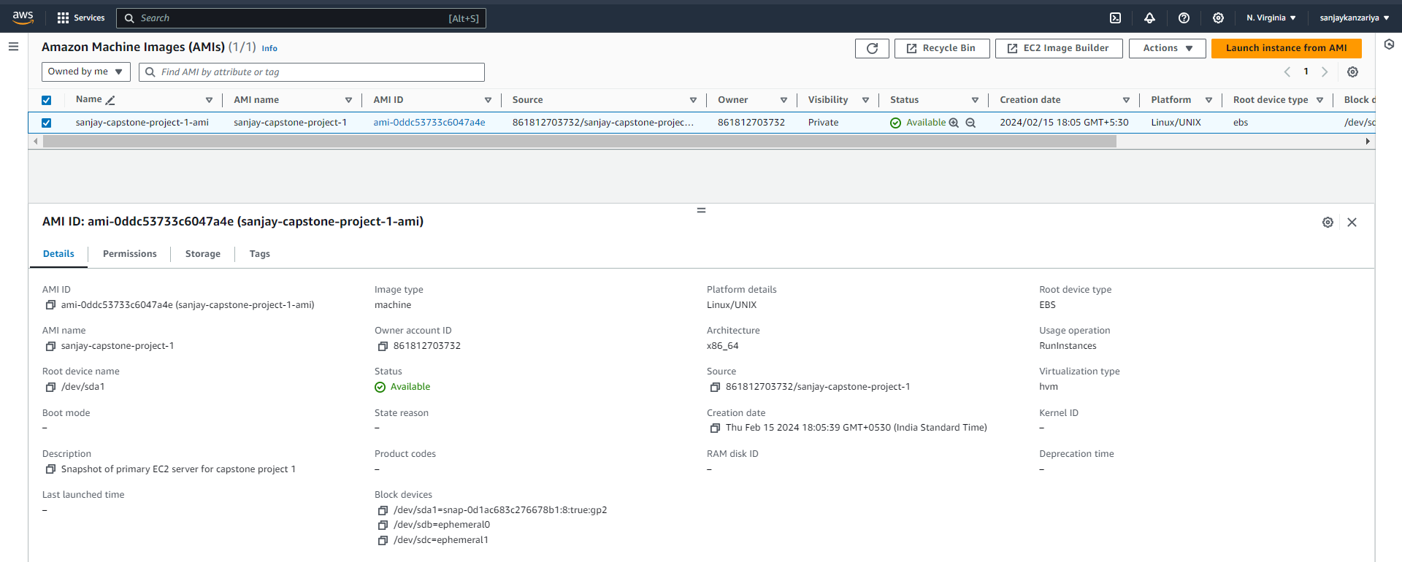

* Creating a Launch Template for Auto Scaling Group!

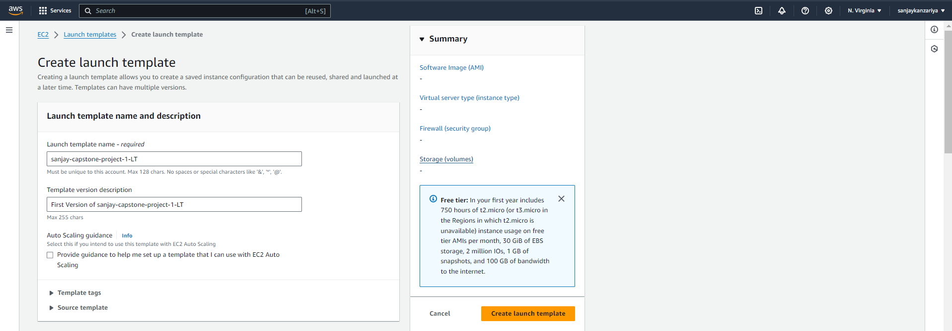

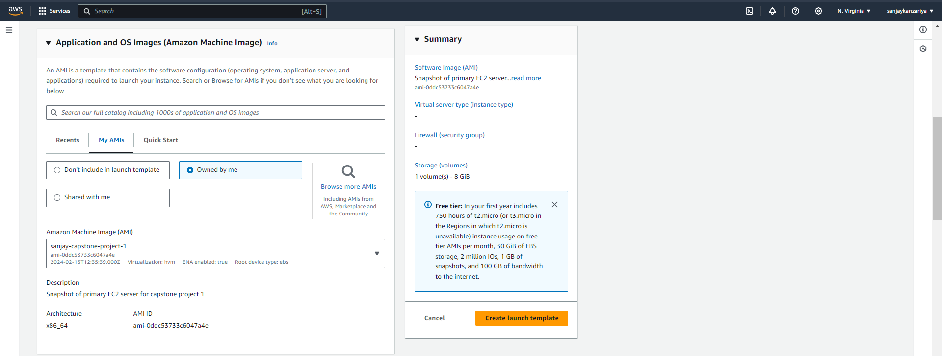

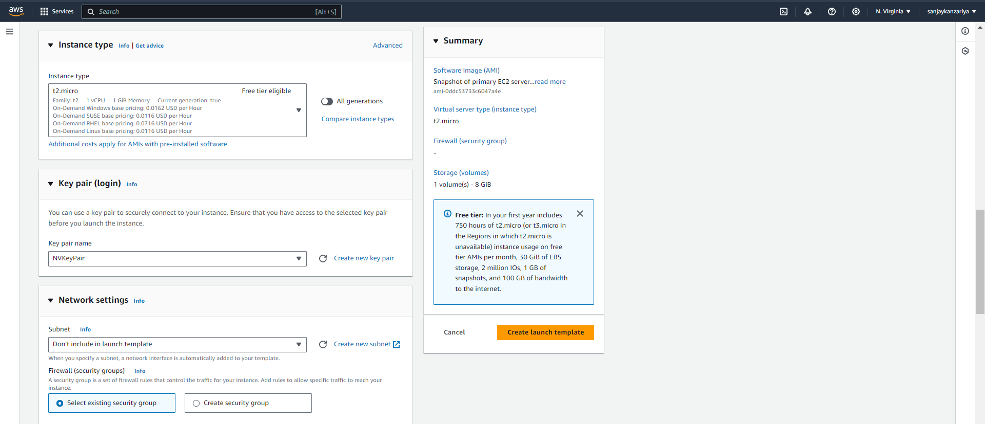

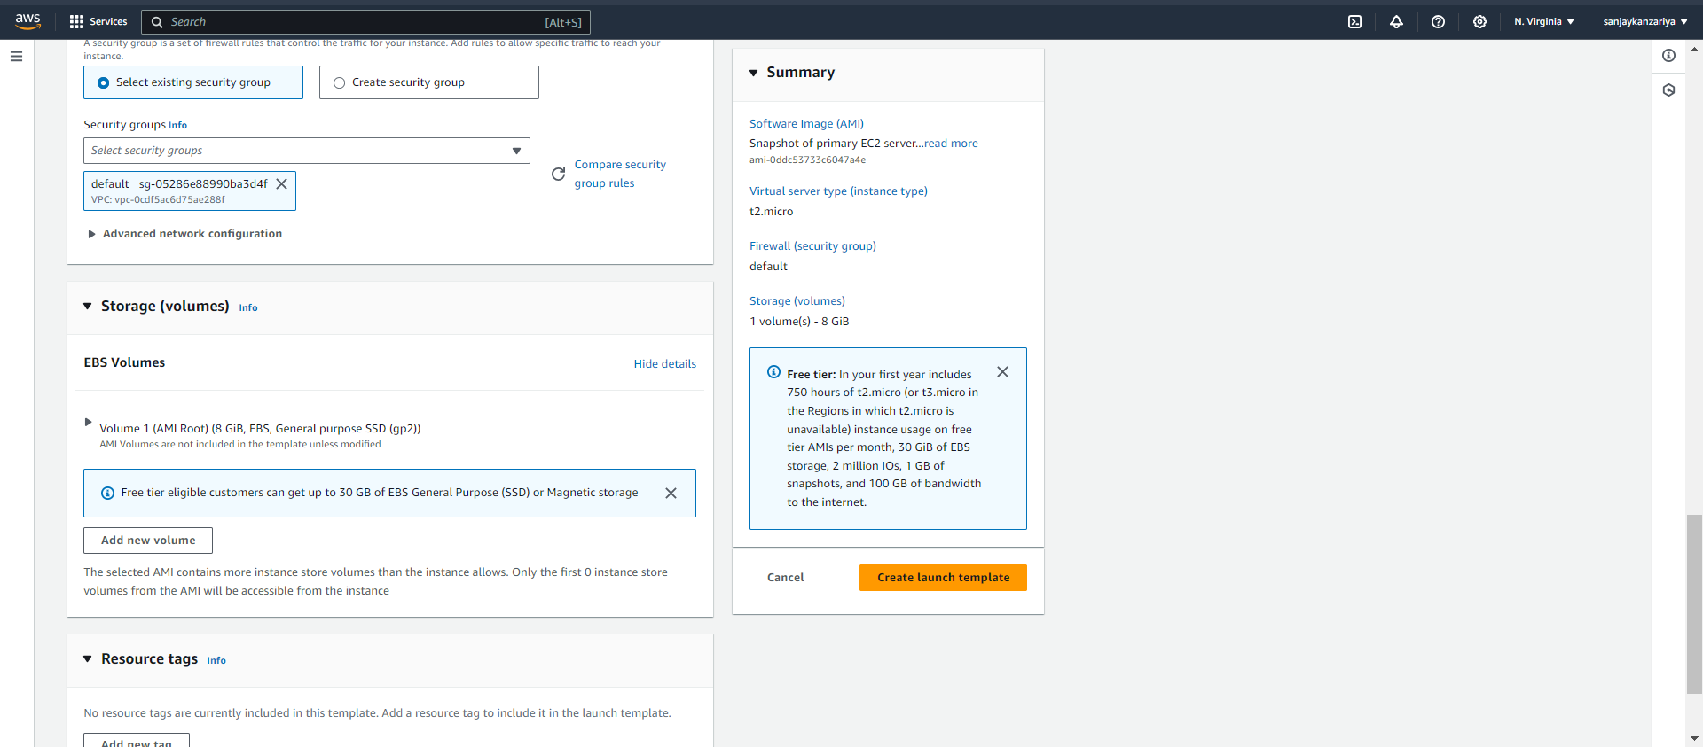

* Creating Auto Scaling Group, with minimum 2 and maximum 4 instances!

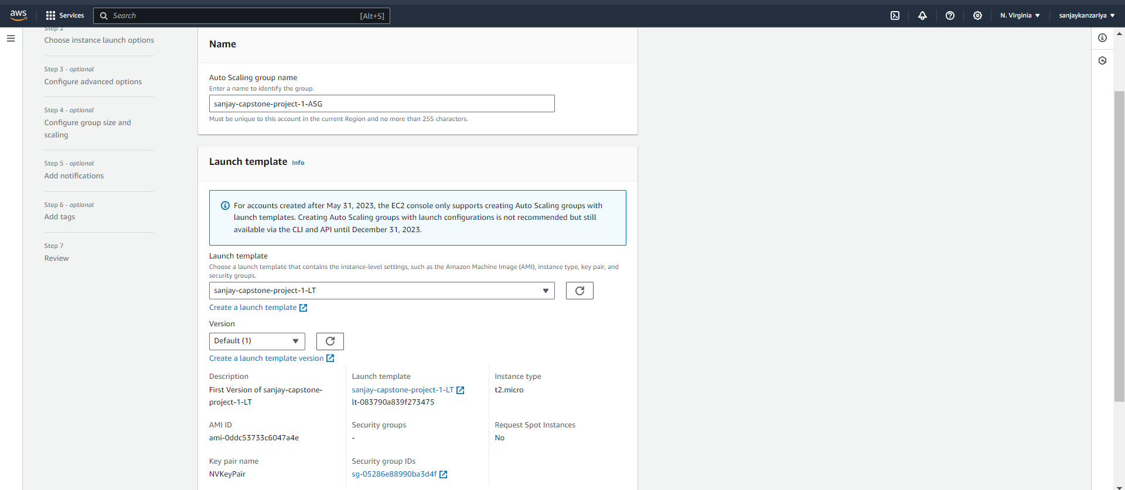

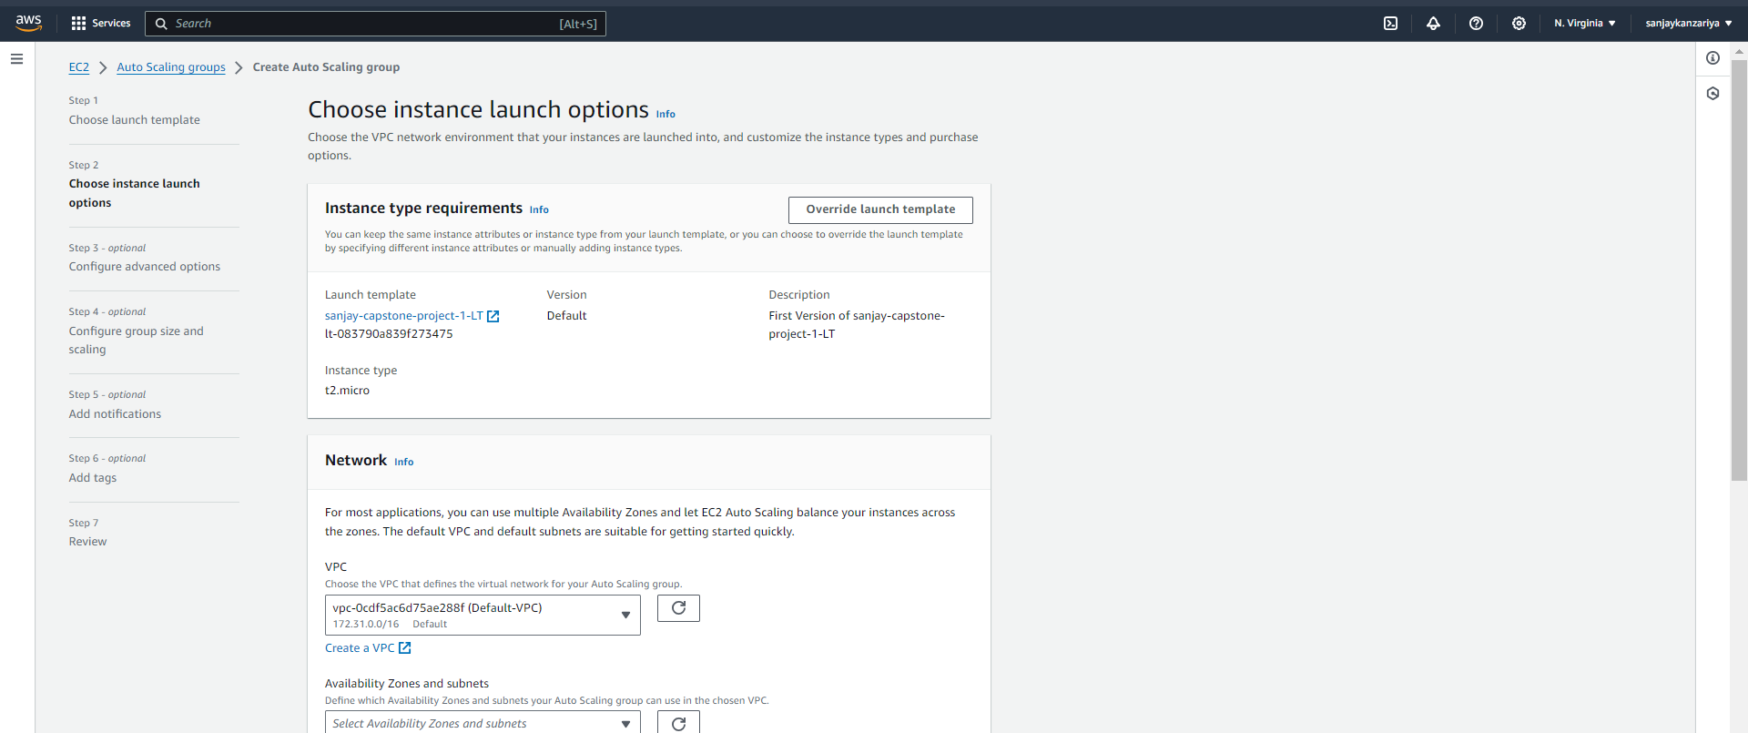

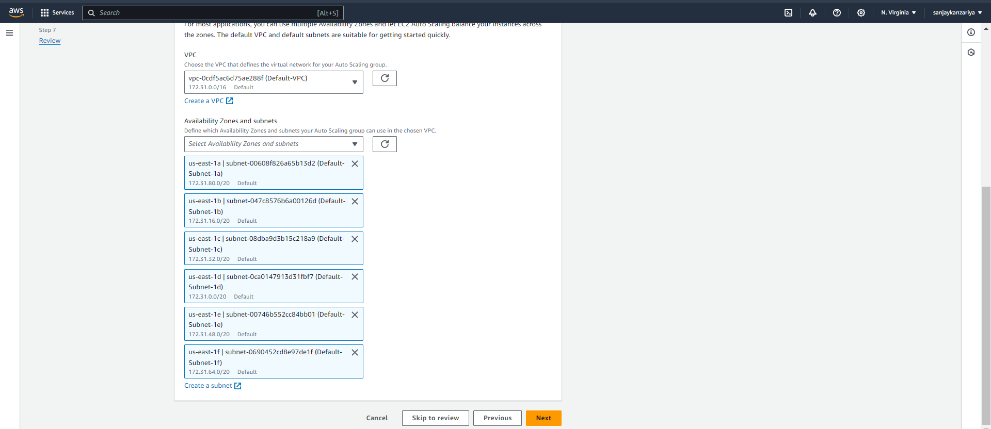

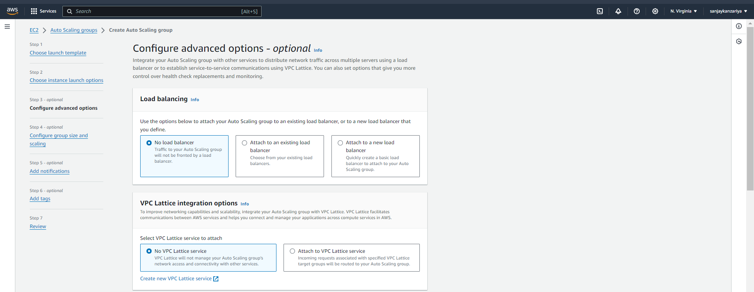

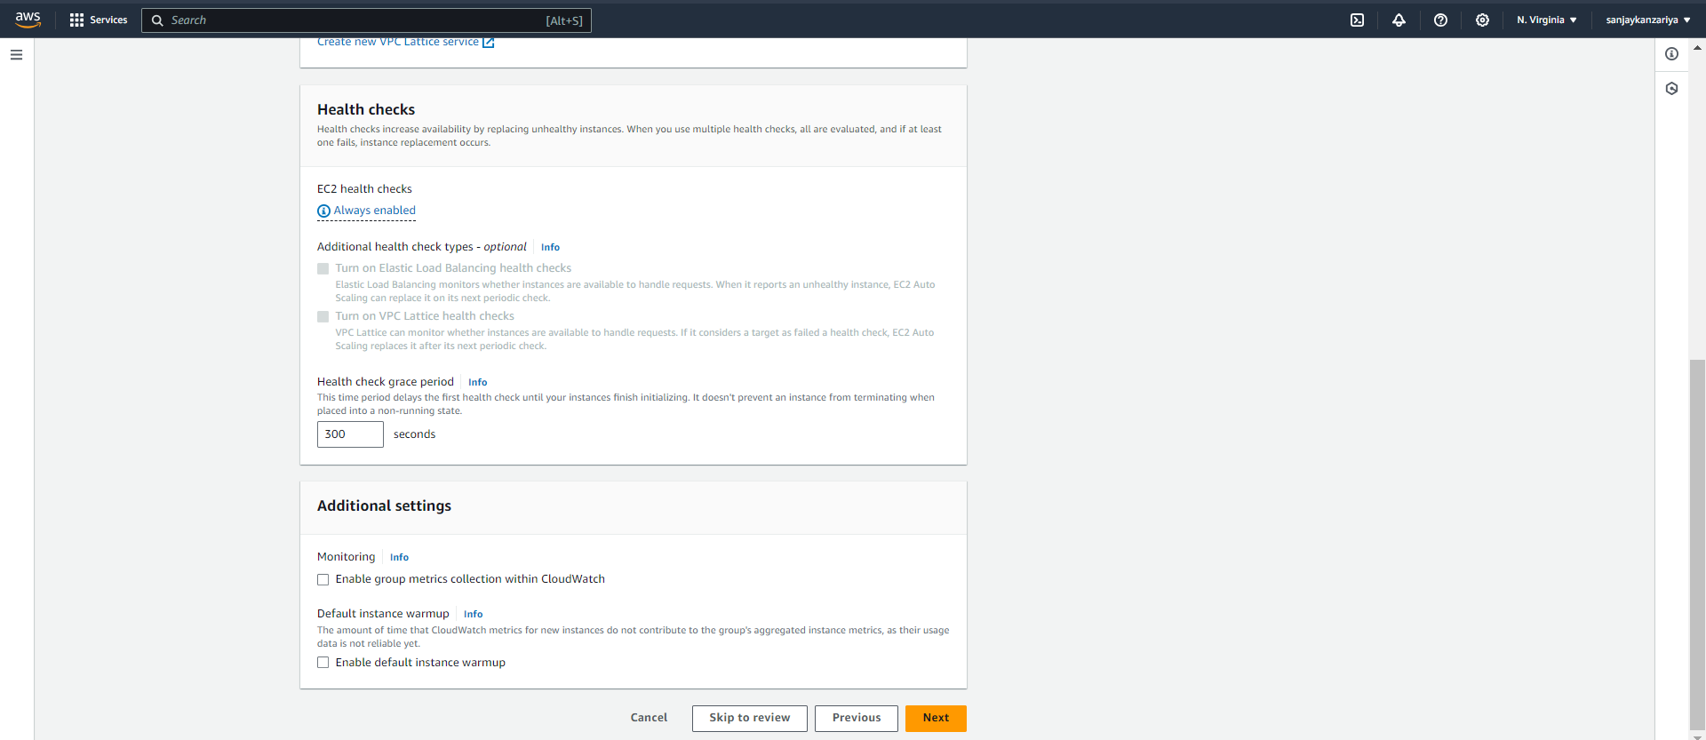

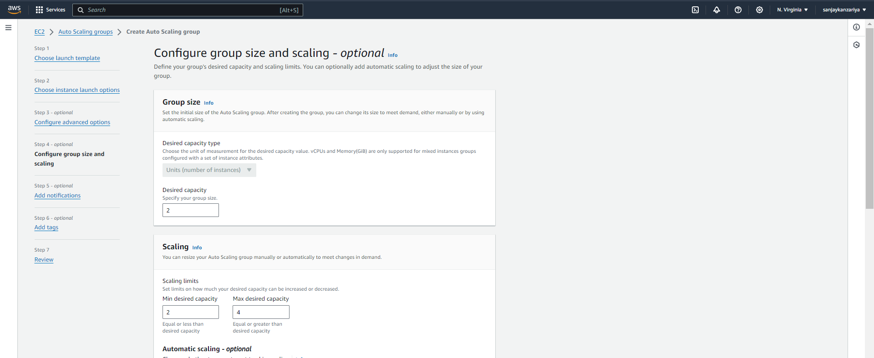

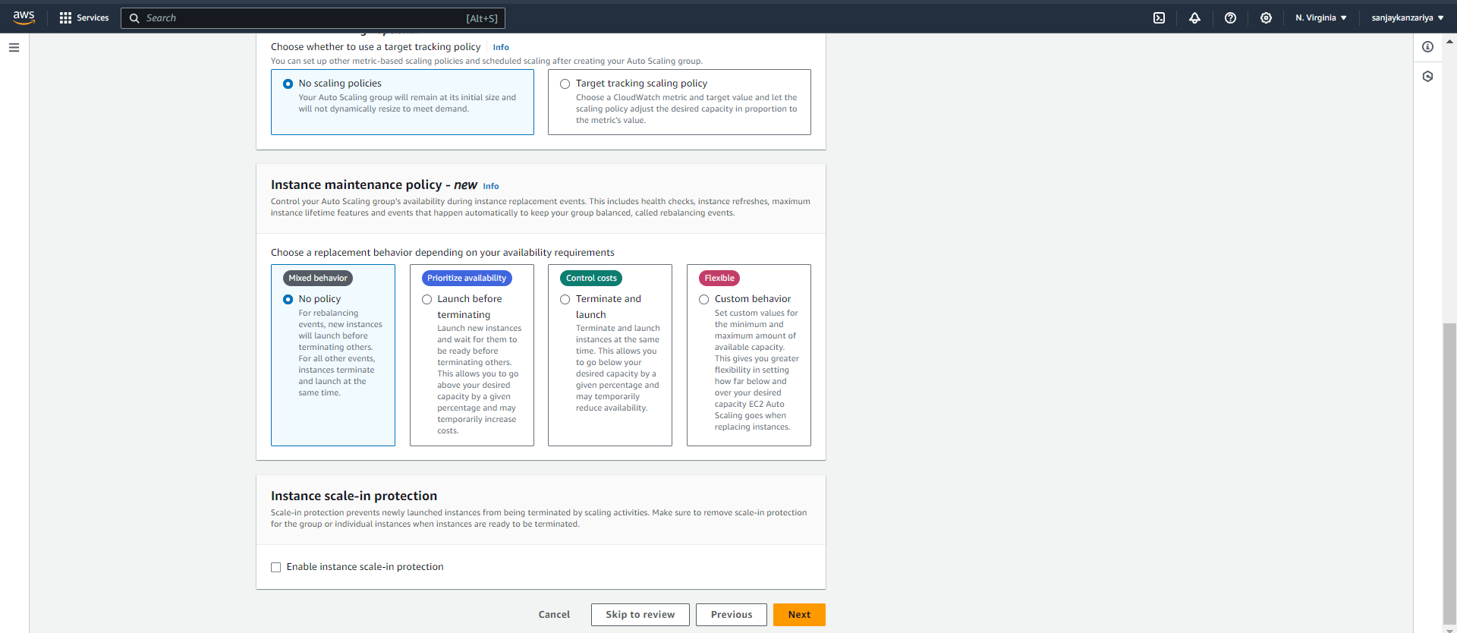

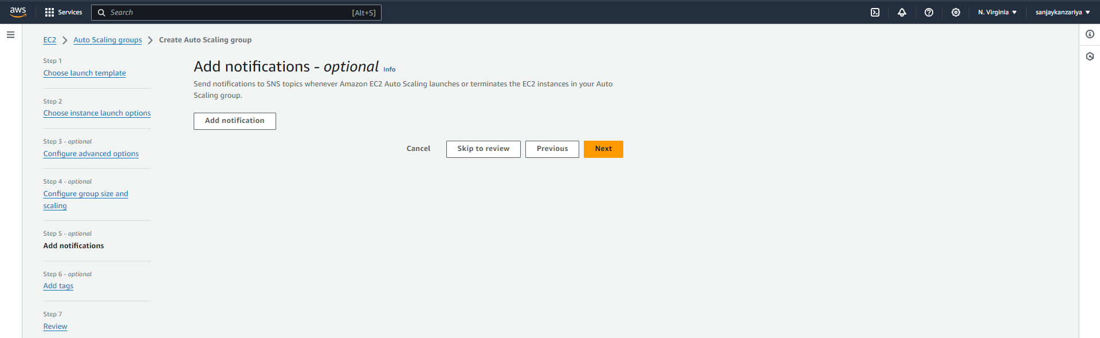

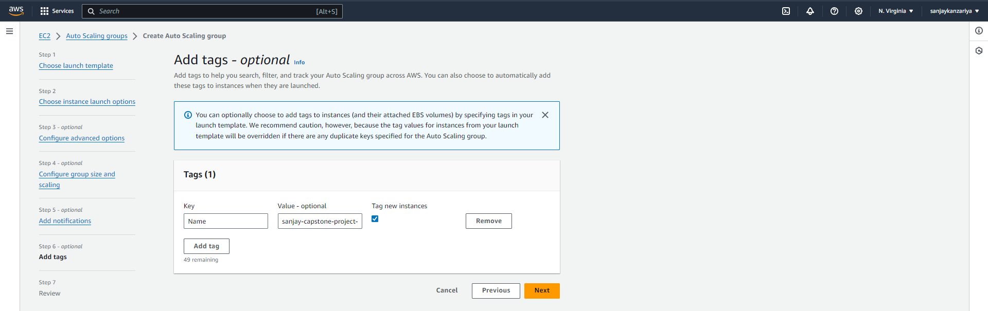

* Two more EC2 instances added as a part of Auto Scaling Group!

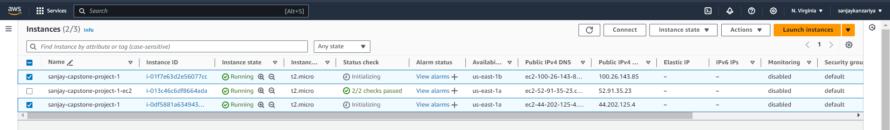

* Checking public webpage of both newly created instances and adding records to the database intel 🡪 table ‘data’!
* First checking on 100.26.143.85!

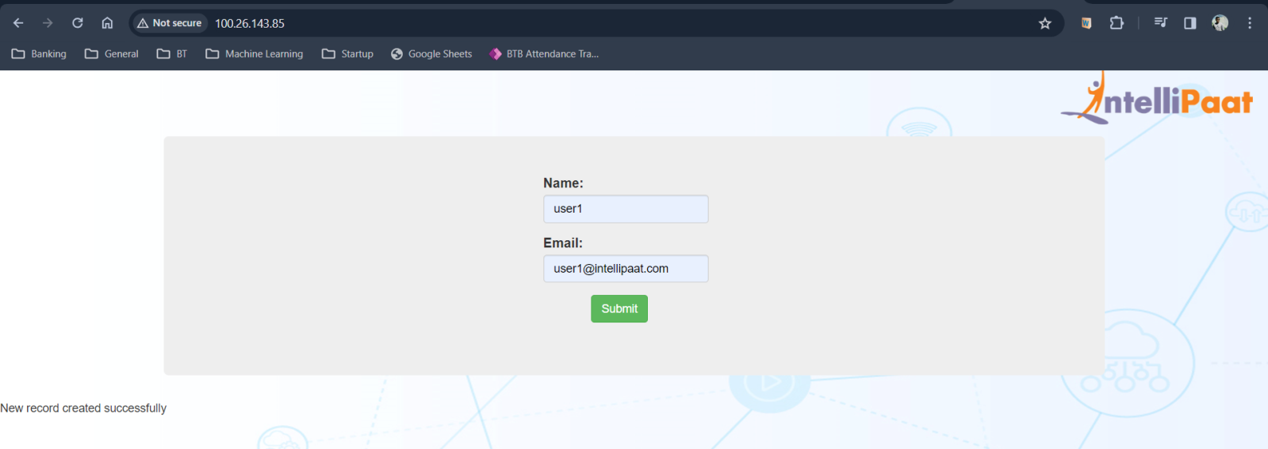

* Now checking on another EC2 instance 44.202.125.4!

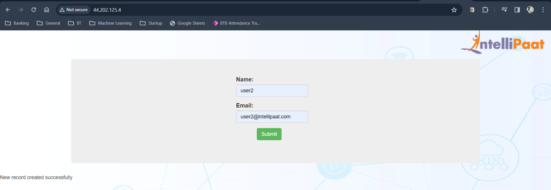

* Checking the ‘data’ table in RDS instance via EC2 server!

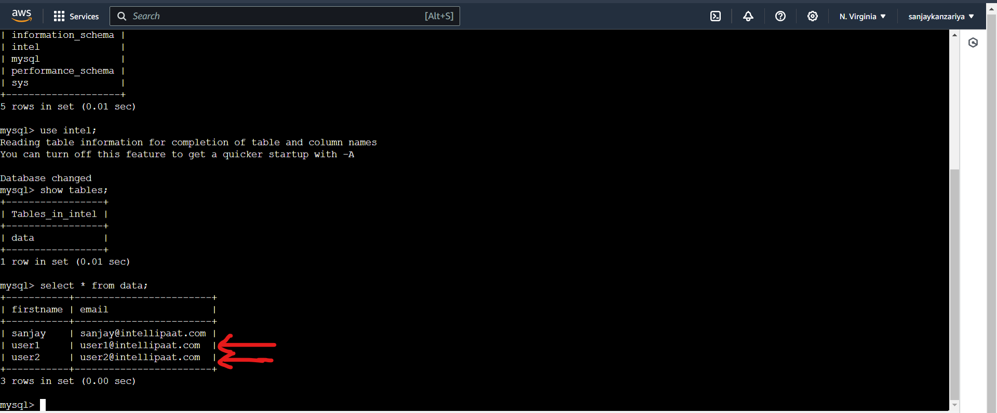

* Now creating Target Group to create Application Load Balancer!

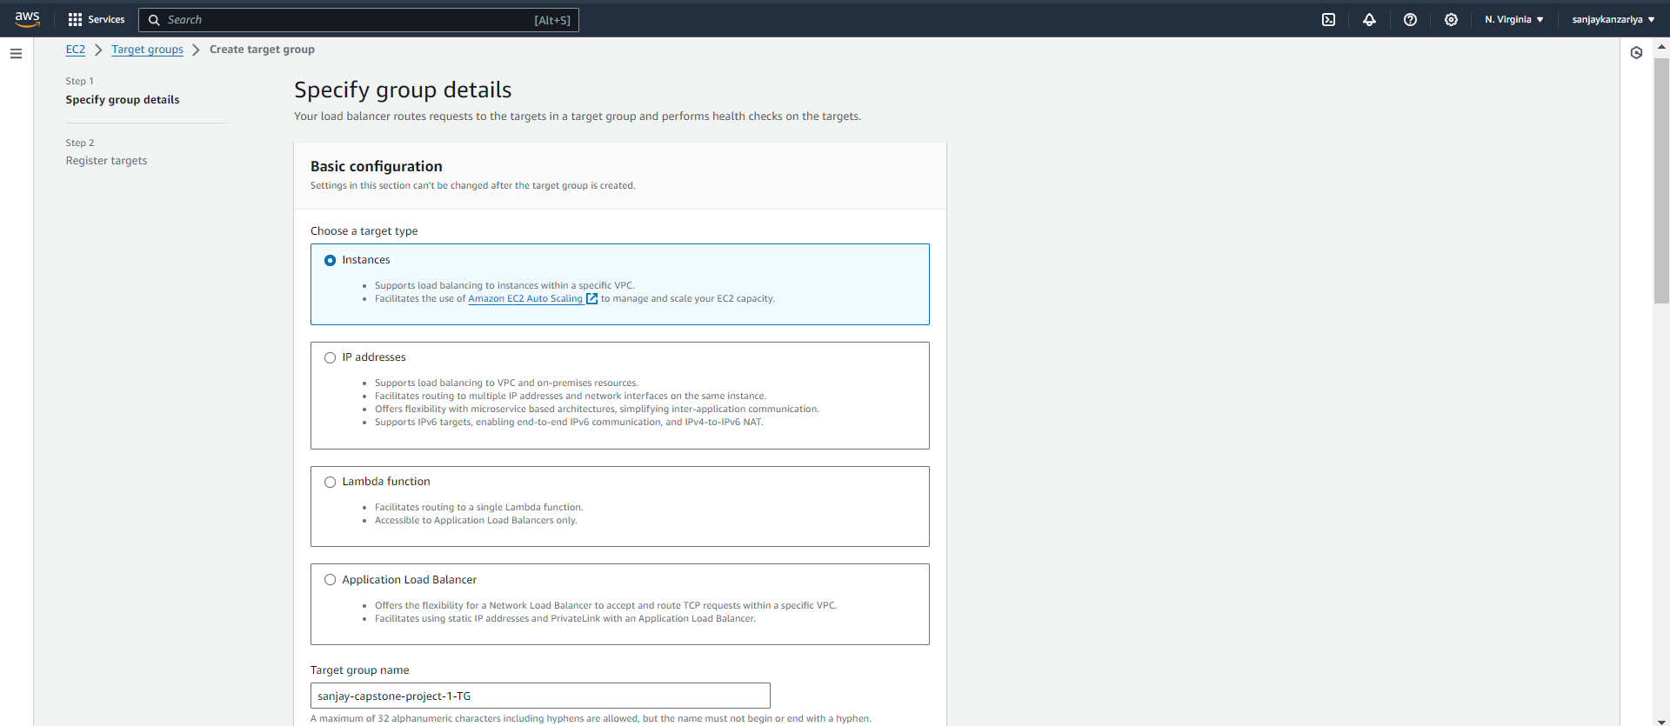

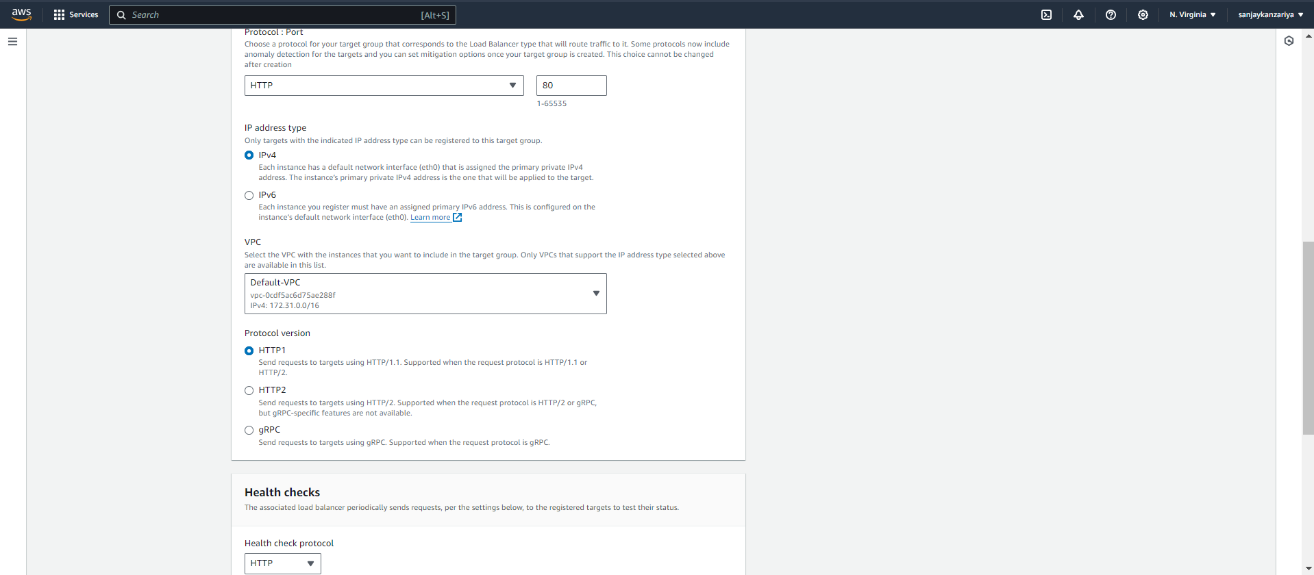

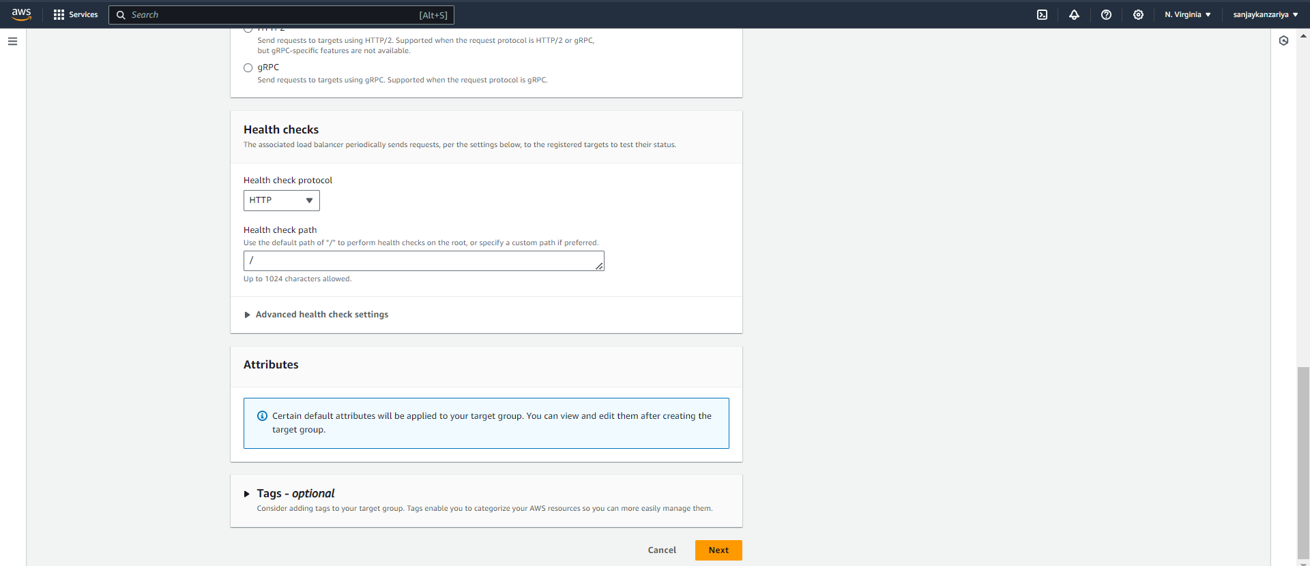

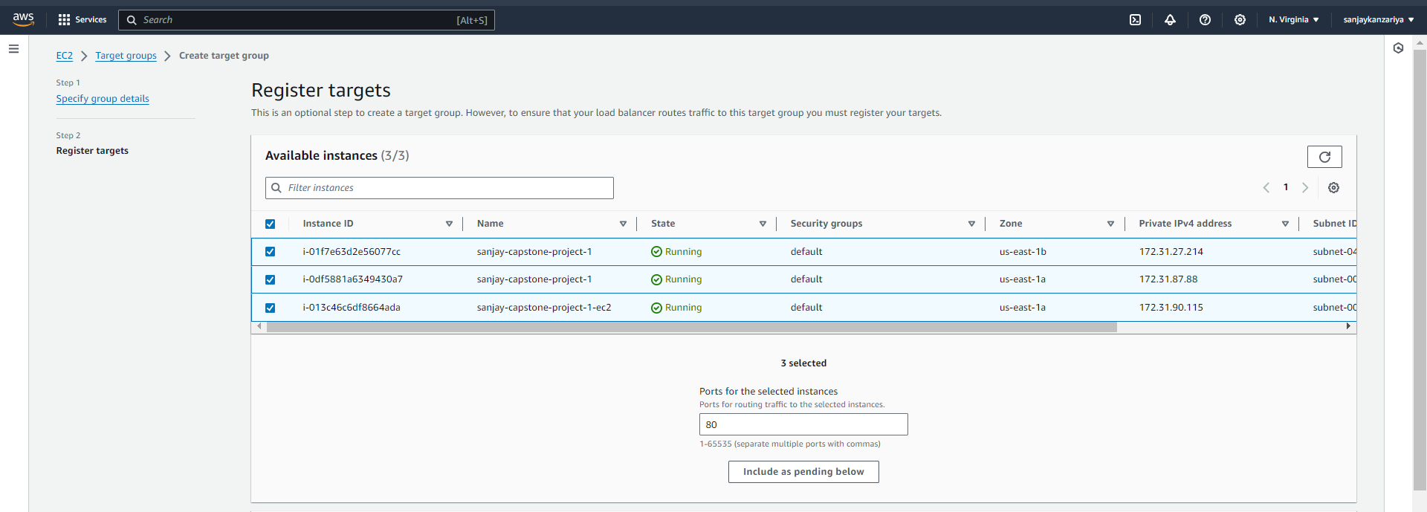

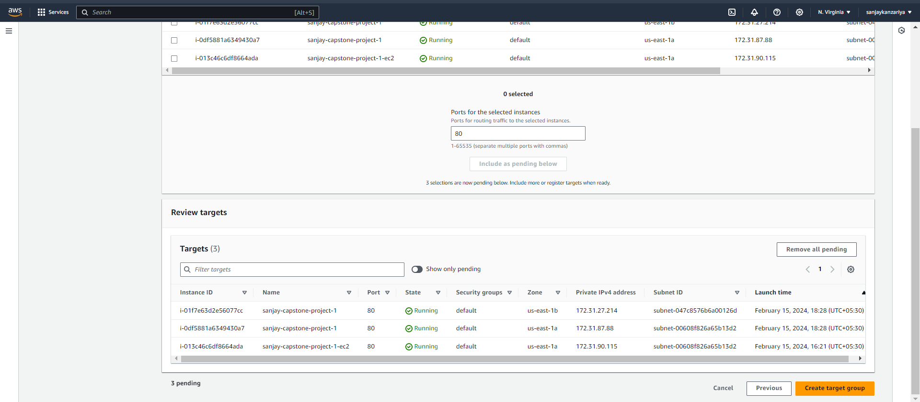

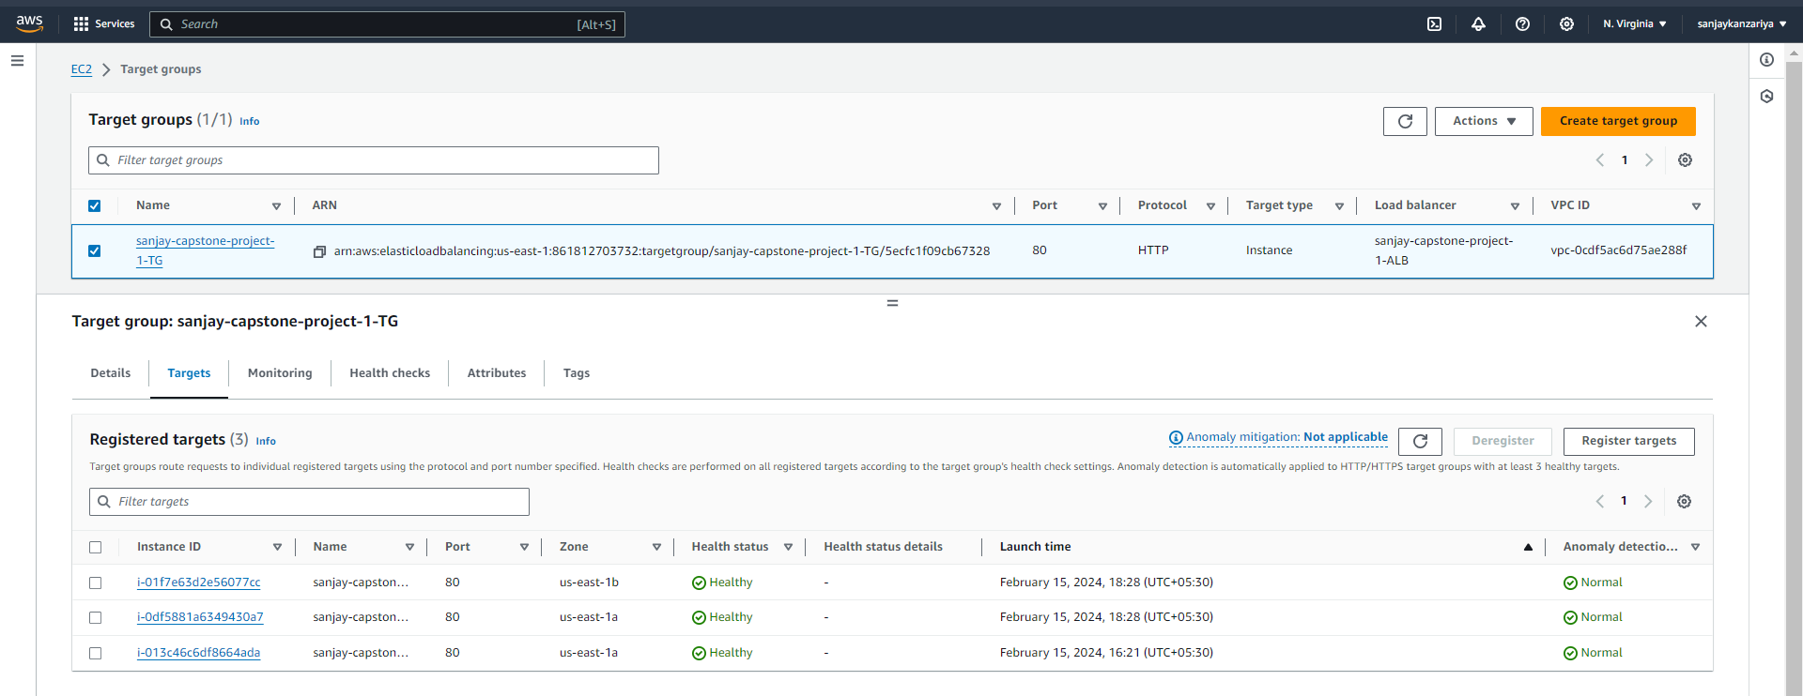

* Creating Application Load Balancer!

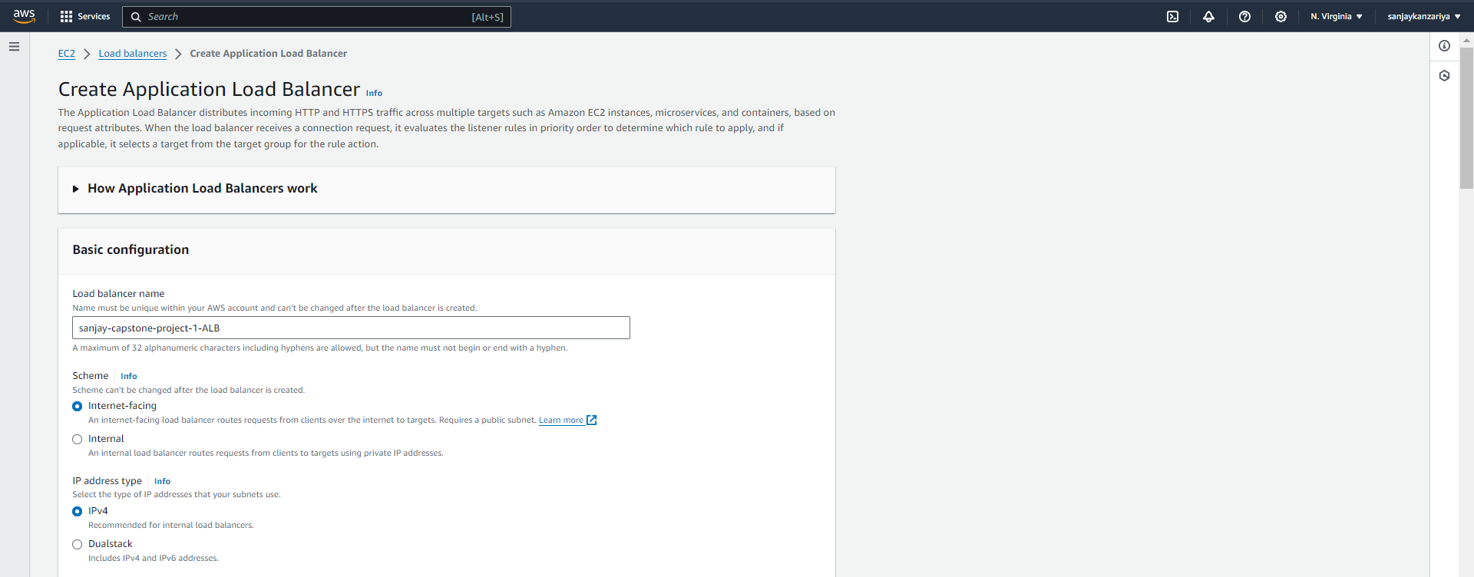

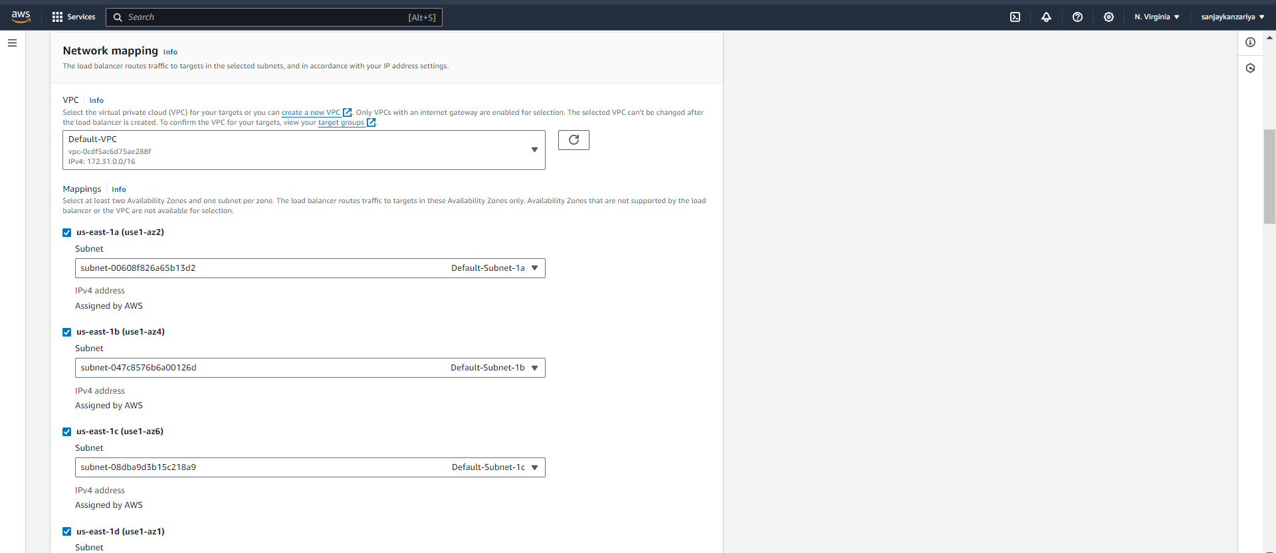

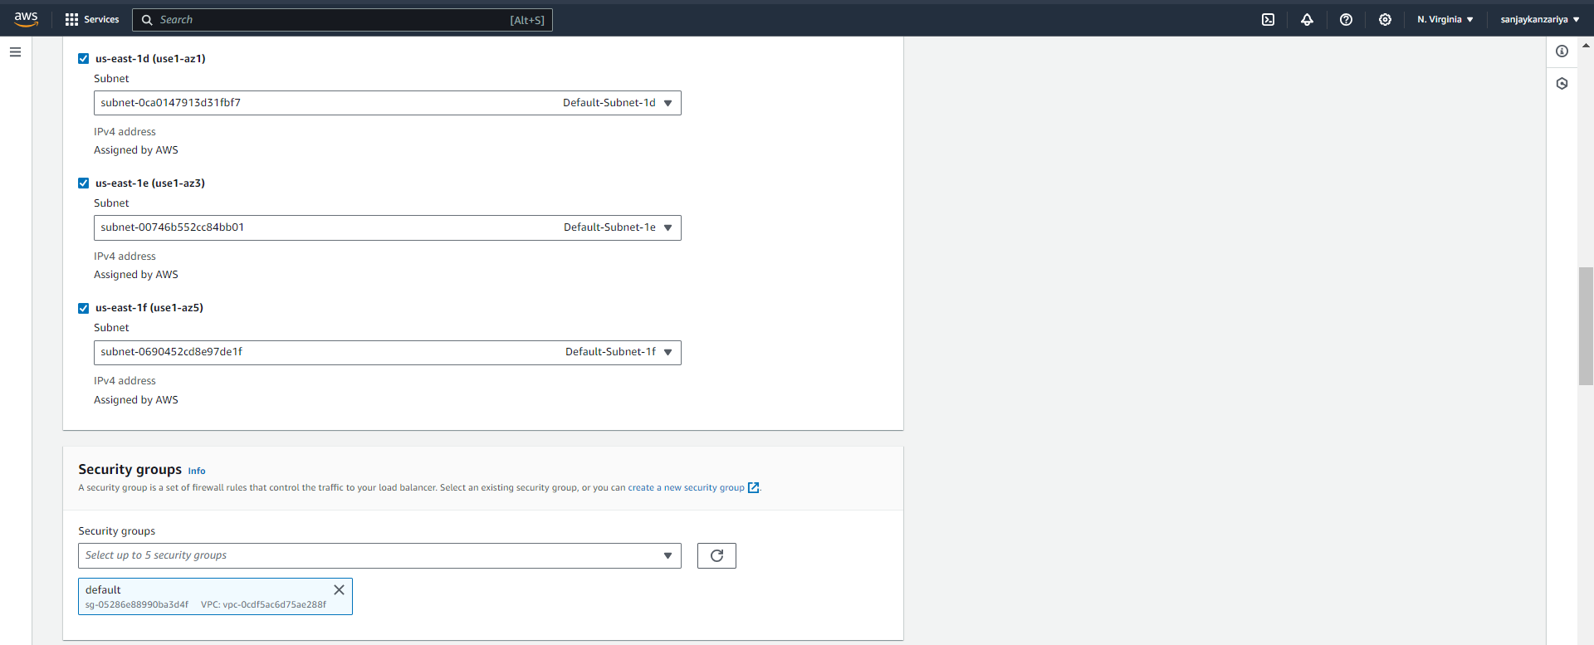

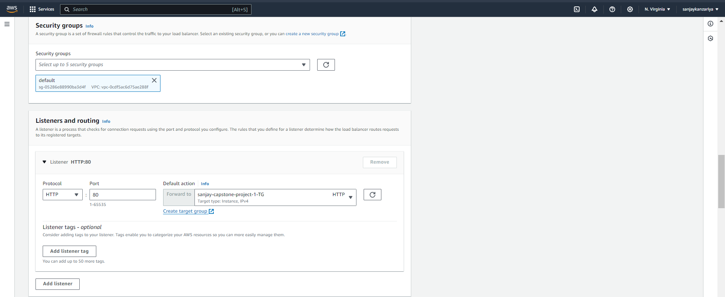

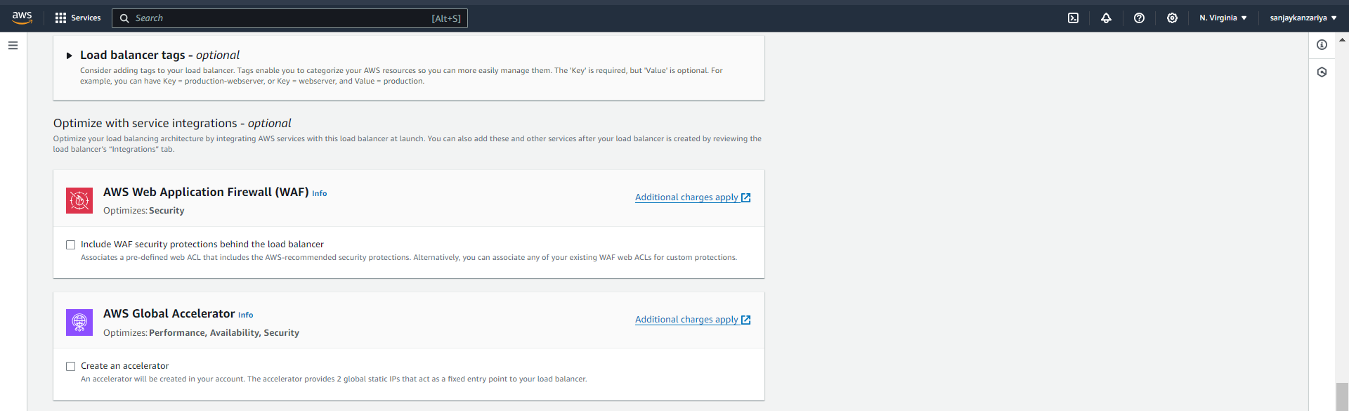

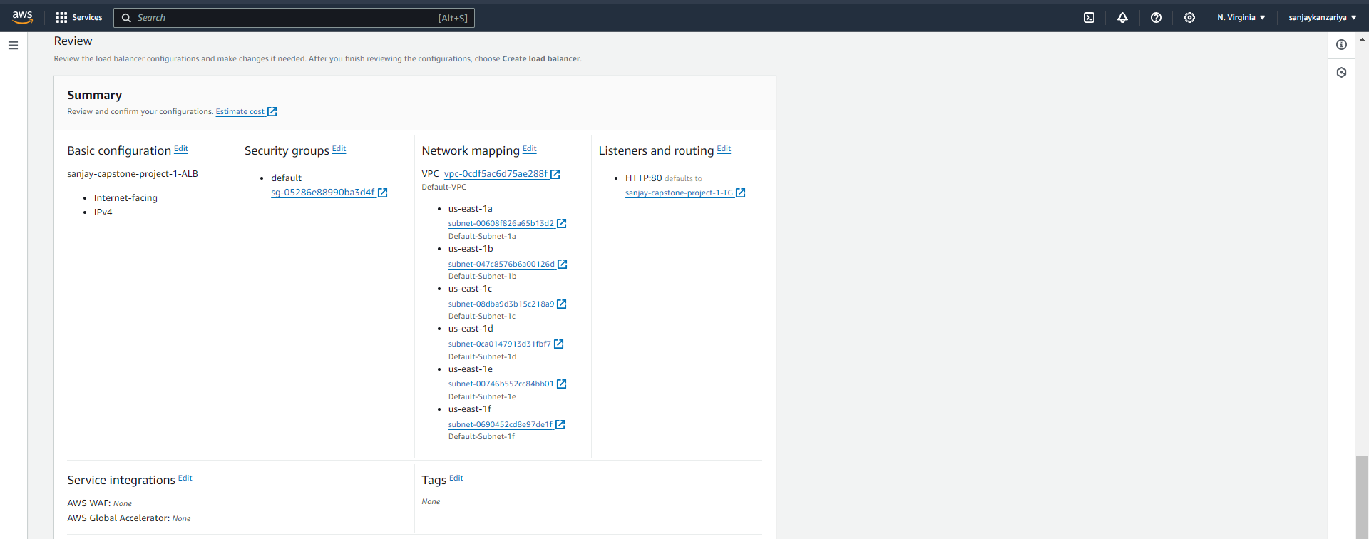

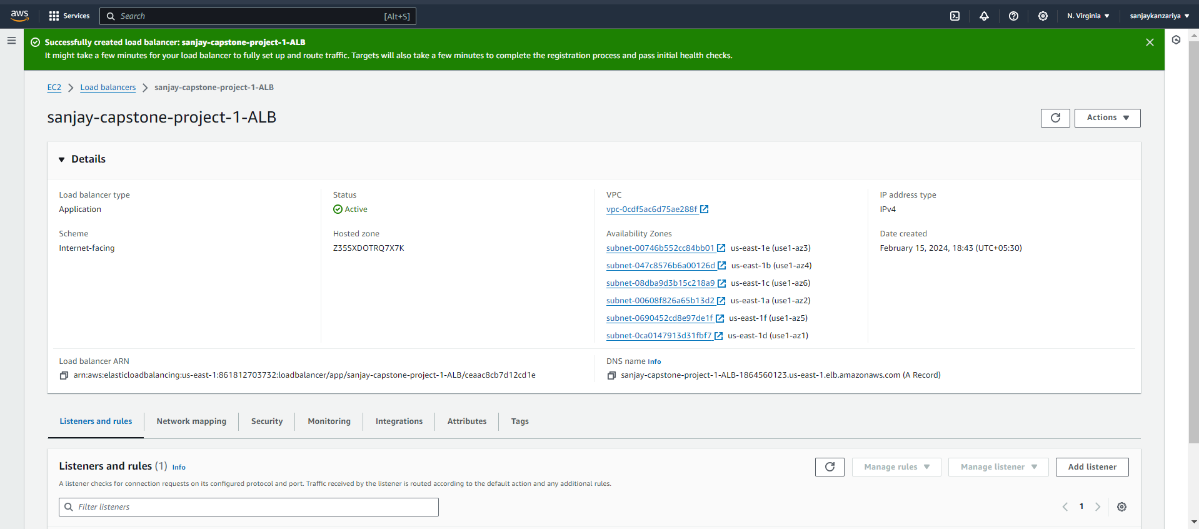

* Checking ALB DNS and adding record to the database!

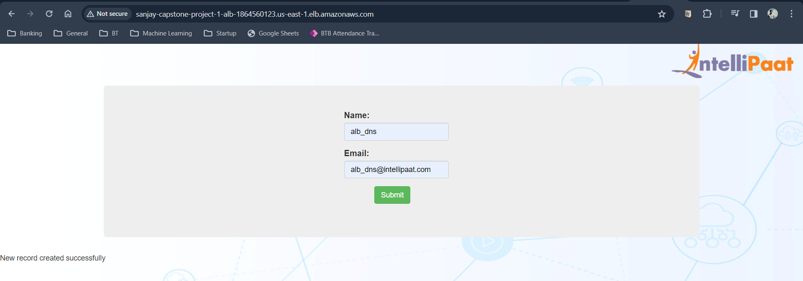

* Confirming the record in intel database!

